College Management System



Submitted by

Hammad Abbas | 55390
Ammara Rasool | 55384

Session: 2021-2025

First Deliverable

College Management System

STATEMENT OF SUBMISSION

This is to certify that the following students have completed the FYP-1 named as: College Management System at the F.G Degree College Gujranwala Cantt and to fulfill the partial requirement of the degree of BS IT.

Sr. No. | Student’s Roll No. | Student’s Name
1 | 55390 | Hammad Abbas
2 | 554384 | Ammara Rasool

Internal Supervisor Head of Department

Prof. Iqbal Kazmi Prof. Yasmeen Nawaz

F.G Degree College, F.G Degree College,

Gujranwala cantt. Gujranwala cantt.

Acknowledgement

First and foremost, we are deeply grateful to Allah for granting us the strength, knowledge, and perseverance to accomplish this milestone. Our heartfelt thanks go to our teachers and Prof. Iqbal Kazmi, our project coordinator, for his invaluable guidance and support. We also appreciate our parents for their prayers and encouragement, which kept us motivated throughout this journey. A special thanks to our team members for their dedication and collaboration. Lastly, we are grateful to everyone who supported and believed in us, making this project a success.

Write to us

We'd love to know what you think about our project. Do you have any questions or ideas? Please share them with us. We appreciate your feedback.

Hammad Abbas

Ammara Rasool

HammadAbbas@gmail.com mailto:abc123@gmail.com
AmmaraRasool18@gmail.com mailto:nerjeret123@gmail.com

Table of Contents
Contents
STATEMENT OF SUBMISSION 2
Table of Contents 6
Chapter 1 6
Project Feasibility Report 6
1.Introduction 7
1.1 Project Feasibility Report 7
CHAPTER 2 9
PROJECT SCOPE 9
2.1 Project Scope 9
CHAPTER 3 11
PROJECT COSTING 11
3.1 Project Costing 11
CHAPTER 4 14
PROJECT PLANNING 14
4.1 Project Scope 14
4.2 CPM – Critical Path Method 15
4.3 Network Diagram 15
4.4 Identify Critical Path 16
4.5 Gantt chart 16
4.6 Introduction to Project Developers 17
4.7 Tools and Technologies with reasoning 17
4.8 Vision Document 18
CHAPTER 5 19
REQUIREMENT ENGINEERING 19
5.1 Introduction 19
5.2 Existing System Business Organization 20
5.3 Scope of the System 21
5.4 Context Level Data Flow Diagram (DFD) 22
CHAPTER 6 23
USECASE DESCRIPTION 23
6.1 Use Case: 23
6.2 Use Case Description 24
Chapter 8 40
Sequence Diagram 40
Login: 40
Admission: 41
Analytical Performance: 42
Schedule: 43
Event: 45
Submit Assignment: 45
Take Quiz: 46
View Result 47
Profile Management: 48
Create Assignment: 49
Create Quiz: 50
Assign Grades: 51
Admin Admission Management: 52
Admin Event Management: 53
Chapter 8 55
CLASS DIAGRAM 55
Class Diagram: 55
Chapter 9 57
Domain diagram 57
Domain Diagram: 57
Chapter 10 59
Collaboration Diagram 59
Collaboration Diagram: 60
Chapter 11 61
Data Model 61
Data Model Diagram: 61
62
CHAPTER 12 63
PROJECT INTERFACES 63
12.1 Admission Screen 63
12.1.1 Course Selection 64
12.1.2 Personal Information 64
12.1.3 Educational Details 64
12.1.4 Upload Documents 65
12.2 Student Pages 65
12.2.2 Student Assignment 66
12.2.3 Submit Assignment Page 66
12.3 Student Quiz 67
12.3.1 Student Quiz Details 67
12.3.2 Student Submit Quiz 68

Chapter 1

Project Feasibility Report

1.Introduction
The College Management System is an advanced web-based platform designed to streamline various academic and administrative tasks within a college. This system provides an online admission portal, enabling students to apply conveniently. It also facilitates assignment and quiz management, allowing teachers to assign tasks and students to submit them digitally. Additionally, students can track their academic progress through interactive charts, enhancing their learning experience. The system includes an admin panel for managing admission schedules, events, and updates, ensuring smooth operations within the institution. By automating these key processes, the College Management System enhances efficiency, accessibility, and communication among students, teachers, and administrators.
- Project Feasibility
- Project Scope
- Project Costing
- Critical Path Analysis (CPM Analysis)
- Gantt Chart
- Introduction to Team Members
- Tools and Technologies
- Vision Document
- Risk List

1.1 Project Feasibility Report
The Feasibility Report outlines the viability of the College Management System, assessing its technical, operational, and economic feasibility. After a thorough analysis, we have determined that the system is practical and can be implemented efficiently. The project encompasses various functionalities, including online admission management, student and faculty information management, course and examination scheduling, user role-based access control, and performance analytics. All necessary resources, including software, hardware, and personnel, are readily available to support its successful execution. The system is designed to streamline administrative and academic processes, improving overall efficiency and user experience. With careful planning, this project is expected to be completed within the allocated time and resources, ensuring smooth implementation and long-term benefits.
- Technical
- Operational
- Economic
- Schedule
- Specification
- Information
- Motivational
- Legal and Ethical

1.1.1 Technical Feasibility
The system is developed using modern web technologies, ensuring high performance, scalability, and security. It features a centralized database for efficient data management and role-based access control to restrict unauthorized access. Additionally, it supports multi-user operations, enabling seamless interaction between students, faculty, and administrators.
1.1.2 Operational Feasibility
The system automates key academic and administrative processes, including online admissions, student performance tracking, faculty course assignments, and exam scheduling. It enhances efficiency by reducing manual workload and improving overall communication and workflow within the institution.
1.1.3 Economic Feasibility
The project requires an initial investment in software and hosting services but significantly reduces long-term operational costs by minimizing paperwork, manual errors, and administrative inefficiencies. The Return On Investment (ROI) is high due to improved productivity and resource optimization.
1.1.4 Schedule Feasibility
With a structured development timeline, the system is planned to be completed in phases, ensuring timely development, testing, and deployment. Agile methodologies and efficient project management techniques help keep the project on track while allowing flexibility for improvements.
1.1.5 Specification Feasibility
The system meets all functional and non-functional requirements, including user-friendly interfaces, secure login mechanisms, efficient data processing, and real-time analytics. It supports various stakeholders, such as students, faculty, and administrators, by providing them with the necessary tools to perform their tasks effectively.
1.1.6 Information Feasibility
The system securely stores and manages student records, faculty data, admission details, course schedules, and performance reports. It ensures data accuracy, integrity, and quick retrieval, providing users with real-time access to relevant information for decision-making.
1.1.7 Motivational Feasibility
The system encourages digital transformation in education, making processes more accessible, transparent, and efficient. It benefits students by providing instant access to academic progress, helps faculty by simplifying grading and assignment management, and assists administrators in handling institutional operations more effectively.
1.1.8 Motivational Feasibility
The system complies with data protection laws and institutional policies, ensuring user privacy, secure data storage, and ethical handling of personal and academic records. It maintains fair usage policies, preventing unauthorized modifications or access to sensitive data.

CHAPTER 2

PROJECT SCOPE

2.1 Project Scope
The College Management System is a comprehensive web-based solution designed to automate and streamline key academic and administrative processes within an educational institution. The system covers online admission management, student and faculty information management, course scheduling, examination handling, role-based access control, and reporting analytics. It facilitates online applications, document submissions, and real-time admission tracking, reducing paperwork and administrative workload. Students can engage in assignments, quizzes, and progress tracking, while faculty members can efficiently manage grading and course assignments. The system also ensures secure data handling by implementing role-based access control, allowing only authorized users to access specific information. Admins can manage exams, course offerings, and generate analytics-based reports to support data-driven decision-making. By enhancing communication, reducing manual errors, and providing real-time insights, this project significantly improves institutional efficiency, benefiting students, faculty, and administrators alike. The integration of modern technology into college management fosters a structured, efficient, and user-friendly academic environment, ensuring seamless operations and enhanced student engagement.

CHAPTER 3

PROJECT COSTING

3.1 Project Costing
For our project cost estimation, we have chosen Function Point Analysis (FPA) as it provides a structured approach to measuring software functionality. Function-oriented software metrics use delivered functionality as a normalization value, which cannot be measured directly but is derived using other quantifiable metrics. Albrecht first introduced Function Points as an empirical method based on countable measures of the software’s information domain and its complexity. Given the diverse functionalities of our College Management System, including admission processing, academic record management, and reporting analytics, FPA helps in accurately assessing the project scope and estimating development costs.

1 | Number of external inputs | 4
2 | Number of external outputs | 3
3 | Number of external inquiries | 3
4 | Number of internal logic files | 7
5 | Number of external logic files | 0
External Inputs
- Student inputs o Assignment submission o Quizzes submission o Personal details updates
- Faculty inputs o Assignments uploads o Quizzes upload o Personal details update
  - Assign assignments/ quizzes numbers
- Admin inputs o Manages student / faculty profiles o Admission management o Schedule management o Events uploads
- Admission Application o Personal details o Academics details o Documents uploads External Outputs
- Student dashboard o Performance charts o Task notifications
- Faculty dashboard o Student performance charts o Class student list
  - Notifications
- Admin dashboard o Reporting analytics on college o admission
External inquiries
- Student performance queries
- Teacher search students
- Admin filter / search student / faculty records
Internal logic files
- Student
- faculty
- admin
- admission
- courses
- schedule
- events
External interface files:
No any external files

3.1.1 Project Cost Estimation By Function Point Analysis

Type of Component | Complexity of components
 | Low | Average | High | Total
External Inputs | 0 | 0 | 4*6 = 24 | 24
External Outputs | 0 | 0 | 7*3 =21 | 21
External Inquiries | 0 | 3*4 = 12 | 0 | 12
Internal logic files | 0 | 2 * 10 = 20 | 5 * 15 = 75 | 95
External interface files | 0 | 0 | 0 | 0
Total Number of Unadjusted Function Points |  |  |  | 152

Value Adjustment Factor
TDI = sum of GSCs
TDI = 53

VAF = (TDI * 0.01) + 0.65
1.18 Adjusted Function points
= UFP * VAF
= 152 * 1.18
=179.36
Effort Estimation
 | = 179.36 * 10
Hourly Rate = 1000  Cost Estimation  Duration of Project | = 1793.6  = 1793.6 * 1000  =1793600
 | = 6 months

CHAPTER 4

PROJECT PLANNING

4.1 Project Scope
The College Management System is a comprehensive web-based solution designed to automate and streamline key academic and administrative processes within an educational institution. The system covers online admission management, student and faculty information management, course scheduling, examination handling, role-based access control, and reporting analytics. It facilitates online applications, document submissions, and real-time admission tracking, reducing paperwork and administrative workload. Students can engage in assignments, quizzes, and progress tracking, while faculty members can efficiently manage grading and course assignments. The system also ensures secure data handling by implementing role-based access control, allowing only authorized users to access specific information. Admins can manage exams, course offerings, and generate analytics-based reports to support data-driven decision-making. By enhancing communication, reducing manual errors, and providing real-time insights, this project significantly improves institutional efficiency, benefiting students, faculty, and administrators alike. The integration of modern technology into college management fosters a structured, efficient, and user-friendly academic environment, ensuring seamless operations and enhanced student engagement.

4.2 CPM – Critical Path Method

4.2.1 Estimate Activity Completion Time
Problem Statement | A
Requirements Gathering and Analysis | B
Planning | C
Software Design | D
Development | E
Testing | F
Deployment | G

Determine the Sequence of the Activities
Some activities are dependent on the completion of others. There are many activities that are dependent on each other
Estimate Activity Completion Time
Activity ID | Predecessor | Duration (Days)
A | None | 1
B | A | 8
C | B | 20
D | C, B | 30
E | D | 60
F | E, D | 15
G | F | 3

4.3 Network Diagram
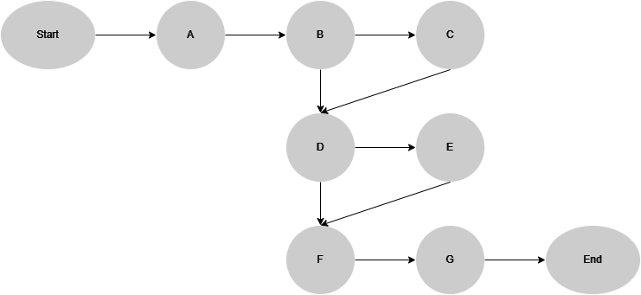

4.4 Identify Critical Path
Activity | Predecessor | Duration | ES | EF | LF | LS | TS
A | None | 1 | 0 | 1 | 9 | 8 | 8
B | A | 8 | 1 | 9 | 9 | 1 | 0
C | B | 20 | 9 | 29 | 39 | 19 | 10
D | B, C | 30 | 9 | 39 | 99 | 69 | 60
E | D | 60 | 39 | 99 | 99 | 39 | 0
F | D, E | 15 | 99 | 114 | 114 | 99 | 0
G | F | 3 | 114 | 117 | 117 | 114 | 0

Critical Path


4.5 Gantt chart
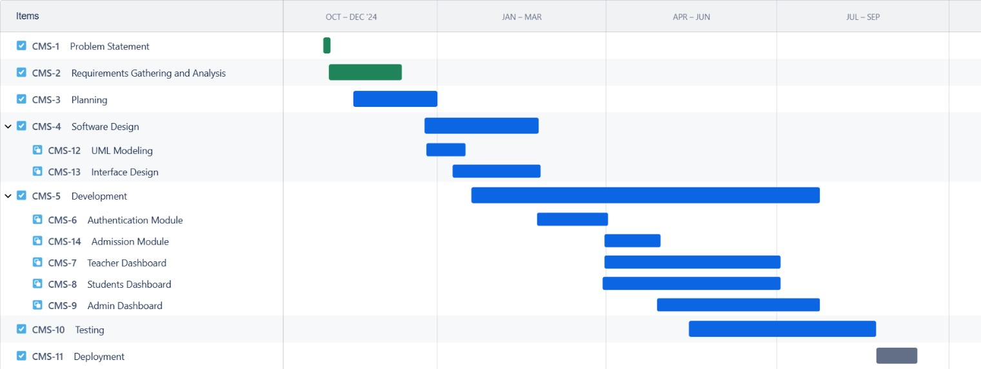

4.6 Introduction to Project Developers

Hammad Abbas and Ammara Rasool
Hammad Abbas and Ammara Rasool are the developers responsible for the development of the College Management System.
Hammad Abbas, with one year of experience as a MERN stack developer, Hammad Abbas has expertise in MongoDB, Express.js, React.js, and Node.js. His responsibilities include frontend and backend development, database management, API integration, testing, debugging, and deployment. Additionally, he oversees system design, project documentation, and ensures the successful implementation of the project.
Ammara Rasool, as a key contributor, collaborates in the development and management of the project. She actively participates in frontend and backend development, database handling, and system design. Her responsibilities also include project documentation, debugging, and assisting in the overall implementation and deployment of the College Management System.

4.7 Tools and Technologies with reasoning
Tools:
Postman (API Testing)
Postman is utilized during the testing phase to validate API endpoints, ensure smooth communication between frontend and backend, and debug issues efficiently.
GitHub (Version Control)
GitHub is used for version control, code collaboration, and project management. It helps in maintaining code integrity, tracking changes, and ensuring backup and security throughout the development lifecycle.
Technologies:
TypeScript
TypeScript is used for strong typing, improved code maintainability, and error detection at compile time. This enhances the reliability and scalability of the frontend application.
React.js with ShadCN (Frontend)
React.js is chosen for its component-based architecture, fast rendering, and reusability, making the UI highly interactive. ShadCN, a UI component library, is used for creating modern, accessible, and visually appealing interfaces efficiently.
Node.js & Express.js (Backend)
Node.js is selected for the backend due to its asynchronous, event-driven architecture, which handles multiple requests efficiently. Express.js is used as the backend framework to create a robust, scalable, and lightweight API.
MongoDB (Database)
MongoDB, a NoSQL database, is used to store and manage student records, faculty details, admission data, and academic information. It allows for flexible schema design, making it ideal for handling dynamic and evolving data structures.

4.8 Vision Document
The vision behind the College Management System is to develop a centralized web-based platform for FG Degree College, addressing the lack of an official digital system for managing key academic and administrative activities. Currently, the college does not have an online platform for admission applications, assignment submissions, quizzes, and performance tracking, making these processes manual and inefficient.
This system aims to streamline and automate these operations, providing students, faculty, and administrators with an easy-to-use, efficient, and accessible solution. With features like online admission processing, student and faculty information management, assignment and quiz submissions, examination scheduling, and real-time performance tracking, the project ensures a modernized, structured, and data-driven approach to college administration. By leveraging MERN stack technologies, the system will offer scalability, security, and a seamless user experience, ultimately enhancing productivity and communication within the college environment.

CHAPTER 5

REQUIREMENT ENGINEERING

5.1 Introduction
The purpose behind developing the College Management System for FG Degree College is to provide a centralized, efficient, and automated platform for handling academic and administrative tasks. Currently, the college lacks a digital system for admissions, assignment and quiz submissions, student performance tracking, and faculty management, leading to manual inefficiencies. By implementing this system, students, faculty, and administrators will have a streamlined process for managing their respective activities.
The system will allow students to apply for admissions online, submit assignments and quizzes, and track their academic progress in real-time. Faculty members can assign coursework, update grades, and manage course-related activities, while administrators can oversee admissions, schedule exams, and generate performance reports. By replacing traditional manual methods with automation, this system will enhance productivity, accessibility, and overall efficiency within the college environment.

5.2 Existing System Business Organization
The College Management System ensures secure authentication and role-based access for students, faculty, and administrators. The system follows a structured process for managing admissions, academics, and faculty activities.
First, a student applies for admission online, and the admin reviews the application. Upon approval, the system automatically generates a Gmail account and password for the student. Once admitted, the student logs into the system using the provided credentials and is redirected to their dashboard, where they can submit assignments, take quizzes, check schedules, view events, and track academic progress.
Similarly, faculty members receive credentials from the admin and log in to access their dashboard, where they can create and assign quizzes, upload assignments, and manage student grades. The admin oversees the entire system, including managing admissions, assigning courses to faculty, scheduling exams, and updating important events.
By automating these processes, the system eliminates manual inefficiencies and provides a centralized, structured, and efficient academic management solution for FG Degree College.

Business Organization Chart
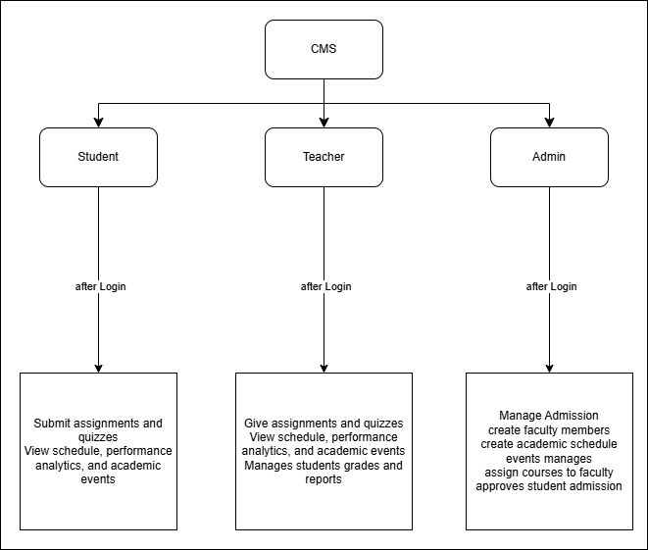

5.3 Scope of the System
The scope of the College Management System (CMS) is to provide a centralized digital platform for managing various academic and administrative operations efficiently. The system is designed to streamline the admission process, allowing students to submit applications online while enabling administrators to review and approve them seamlessly. It also facilitates student and faculty management, where student profiles, academic records, and faculty assignments can be securely maintained. The CMS allows teachers to assign quizzes and assignments, while students can submit their work and track their progress through performance analytics. Additionally, the system provides course management, examination scheduling, role-based access control, and real-time reporting and analytics to ensure smooth academic operations.

The implementation of this system will bring numerous benefits, such as reducing manual workload, improving efficiency in student admissions, enhancing communication between students, teachers, and administrators, and ensuring data security. The system will also help monitor student performance, automate administrative tasks, and provide better decision-making insights through analytics. Overall, the CMS will serve as a scalable and efficient solution for managing academic processes in FG Degree College, ensuring a better educational experience for all stakeholders.

5.4 Context Level Data Flow Diagram (DFD)
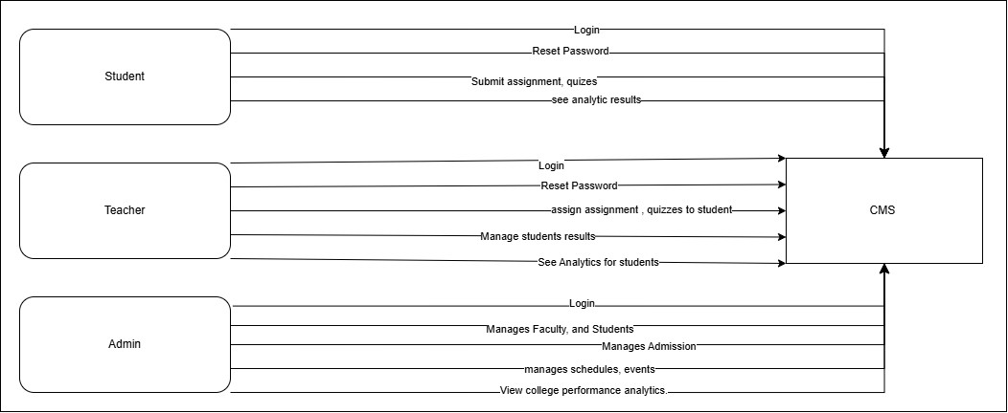

CHAPTER 6

USECASE DESCRIPTION

6.1 Use Case:
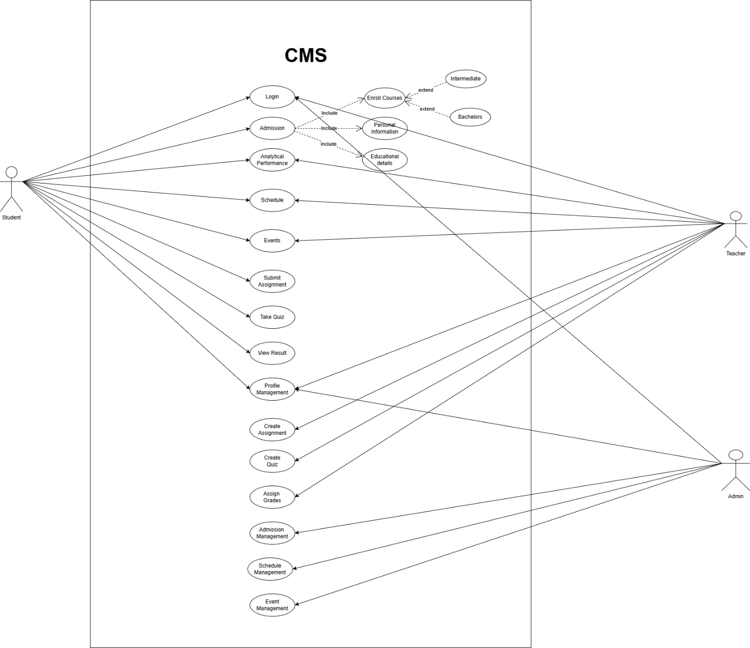

6.2 Use Case Description
Following are the use cases that we have used in our project
UC_1 Login
Brief description:
User will login in the app.
Scope: CMS
Level: User
Primary actor: Student/Teacher/Admin
Precondition:
• User must have internet connection.
Main success scenario:
- User open the web login page.
- User enters the login credentials.
- Click to login.
Alternate flows:
- If you are not connected to Wi-Fi then connect.
- If you are not login then login first.
Post conditions:
User login the app successfully and start performing the tasks.

UC_2 Admission
Brief description:
User will apply for admission in the college by selecting specific courses.
Scope: CMS
Level: User
Primary actor: Student
Precondition:
• User must have internet connection.
Main success scenario:
- User navigates to the Admission page in the CMS.
- User selects their desired course (Intermediate or Bachelors programs).
- User enters their personal information (e.g., name, contact details, etc.).
- User provides educational details, including Board name, marks obtained, year of completion, and two additional input fields.
- User uploads the required documents (e.g Result Card).
- User clicks the Submit button to submit the admission form.
- System confirms successful submission of the admission form.
- Admin reviews the submitted information and evaluates the applicant based on merit.
- Applicant receives notification of acceptance or rejection from the system.
Alternate flows:
- If the user is not connected to the internet, they need to connect before proceeding.
- If the uploaded document format is incorrect, the system prompts the user to upload a valid format.
- If the educational details or personal information are incomplete, the system notifies the user to provide the missing information.
- If the applicant does not meet the merit criteria, the admin rejects the application, and the user is notified via the system.
Post conditions:
The user successfully submits the admission form, and the admin processes the application, resulting in either acceptance or rejection, with the user receiving a confirmation or notification through the CMS.

UC_3 Analytical Performance
Brief description:
A user views their academic performance analytics in the CMS, including a week-based line graph of performance percentages and circular graphs showing completion status for assignments and quizzes, as well as marks obtained versus total marks for results.
Scope: CMS
Level: User
Primary actor: Student/Teacher
Precondition:
- User must have internet connection.
- User must log in to the CMS.
- The semester must have started, and at least one week of the semester must be complete for the weekly performance graph to be available.
Main success scenario:
- User navigates to the Analytical Performance section in the CMS.
- System checks if the semester has started and at least one week is complete.
- If yes, the system displays a line graph showing the user’s performance percentage over the past week(s).
- If no, the system informs the user that the graph is unavailable until the first week of the semester is complete.
- User views circular graphs for:
- Assignments: Showing completed, uncompleted, and in-progress assignments.
- Quizzes: Showing completed, uncompleted, and in-progress.
- Results: Displaying marks obtained (e.g., 10/20, where 10 is the marks gained and 20 is the total marks possible).
- User reviews the analytics to assess their academic progress.
Alternate flows:
- If the user is not connected to the internet, they need to connect before proceeding.
- If the user is not logged into the CMS, they must log in first.
- If the semester has not started or the first week is incomplete, the system displays a message: “Weekly performance graph unavailable. Please check back after the first week of the semester.
- If no data is available for assignments, quizzes, or results, the system notifies the user:
“No data available for this category.
- If there is an error in retrieving performance data, the system displays an error message and prompts the user to try again later.
Post conditions:
The user successfully views their analytical performance data, including the weekly line graph (if available) and circular graphs for assignments, quizzes, and results, allowing them to monitor their academic progress in the CMS. The user successfully views their analytical performance data, including the weekly line graph (if available) and circular graphs for assignments, quizzes, and results, allowing them to monitor their academic progress in the CMS.

UC_4 Submit Assignment
Brief description:
Student will submit an assignment in the CMS
Scope: CMS
Level: User
Primary actor: Student
Precondition:
- User must have internet connection.
- User must login into the CMS.
Main success scenario:
- User navigates the course page.
- User selects the assignment to be submitted.
- User uploads the assignment file.
- Click on Submit button
- System confirms successful submission.
Alternate flows:
- If the user is not connected to Wi-Fi, they need to connect before proceeding.
- If the user is not logged into the LMS, they must log in first.
- If the file format is incorrect, the system prompts the user to upload a valid format.
- If the deadline has passed, the system prevents submission and notifies the user.
Post conditions:
User will successfully submit the assignment and receives a confirmation.

UC_5 Take Quiz
Brief description:
Student will attempt a quiz in the CMS.
Scope: CMS
Level: User
Primary actor: Student
Precondition:
- User must have internet connection.
- User must login into the system.
- Quiz must be available and not expired.
Main success scenario:
- User navigates to the course page.
- User selects the available quiz.
- User reads the quiz instructions and starts the quiz.
- User answers the quiz questions within the given time.
- User submits the quiz before the deadline.
- System confirms successful submission and records the attempt.
Alternate flows:
- If the user is not connected to Wi-Fi, they need to connect before proceeding.
- If the user is not logged into the LMS, they must log in first.
- If the quiz has expired, the system prevents access and notifies the user.
- If the user exits the quiz before submission, the system may autosave progress if allowed.
Post conditions:
User successfully completes and submits the quiz, and the system records the attempt. They are notified once the instructor completes grading.

UC_6 View Result
Brief description:
User will view their Mid-term exam result.
Scope: CMS
Level: User
Primary actor: Student
Precondition:
- User must have an internet connection.
- User must be logged into the LMS.
- The result must be available for viewing (grades)
Main success scenario:
- User navigates to the Result page.
- System displays the result, including marks for their specific subjects
Alternate flows:
- If the user is not connected to Wi-Fi, they must connect before proceeding.
- If the user is not logged in, they must log in first.
- If the result is not yet published, the system notifies the user.
- The user can review his result for specific subjects
Post conditions:
The system successfully displays the user's result. This allows them to track progress, understand mistakes, and plan for improvement in future assessments.

UC_7 Schedule
Brief description:
Student will view his time table schedule and exams schedule.
Scope: CMS
Level: User
Primary actor: Student/Teacher
Precondition:
- User must have internet connection.
- User must login into the CMS.
- The scheduling feature must be available.
Main success scenario:
- User navigates to the scheduling section in the CMS.
- User selects the type of Schedule (e.g. Time Table, Exams).
- User will view the selected schedule.
Alternate flows:
- If the user is not connected to Wi-Fi, they must connect before proceeding.
- If the user is not logged in, they must log in first.
- First user will select the schedule then he can view his selected schedule

Post conditions:
User can successfully see schedule.

UC_8 Events
Brief description:
User can see the college events in the CMS.
Scope: LMS
Level: User
Primary actor: Student /Teacher
Precondition:
- User must have internet connection.
- User must login into the CMS.
- Events must be available for viewing.
Main success scenario:
- User navigates to the "Events" section in the CMS.
- User browses through available events.
- User selects a specific event to view details.
- User can view the images of the event.
Alternate flows:
- If the user is not connected to Wi-Fi, they must connect before proceeding.
- If the user is not logged in, they must log in first.
- If registration is not required, the user can directly view event details and attend at the scheduled time.

Post conditions:
The event is successfully added to the user's schedule, and they receive notifications or reminders (if enabled). The user can access event details and participate when the event takes place.

UC_9 Profile Management
Brief description:
User will manage their profile information in the CMS.
Scope: CMS
Level: User
Primary actor: Student/Teacher/Admin
Precondition:
- User must have internet connection.
- User must login into the system.
Main success scenario:
- User navigates to the "Profile" section in the LMS.
- User views their current profile details.
- Based on the user role:
- Student can manage:
  - Forgot Password
  - Address
  - Phone Number
- Teacher can edit:
  - Name
  - Qualification
  - Post
  - Research Interest
- Admin can modify:
  - Name
  - Email ID
  - Forgot Password
- User saves the changes.
- System validates the input and confirms the update.
- The updated profile details are reflected across the CMS.
Alternate flows:
- If the user is not connected to Wi-Fi, they must connect before proceeding.
- If the user is not logged in, they must log in first.
- If mandatory fields are left blank, the system prompts the user to complete them.
Post conditions: User’s profile is successfully updated, and the changes are saved in the CMS. The updated details are reflected across the system, ensuring accurate user information.

UC_10 Create Assignment
Brief description:
User will create an assignment in the CMS and provide relevant details for students.
Scope: CMS
Level: User
Primary actor: Teacher
Precondition:
- The user must have an active internet connection.
- The user must be logged into the system with a teacher role.
Main success scenario:
- The teacher navigates to the "Assignments" section in the LMS.
- The teacher selects the option to create a new assignment.
- The system prompts the teacher to enter the assignment details, including:
- Title
- Description
- Due Date
- Total Marks
- Attachment (optional)
- The teacher submits the assignment.
- The system validates the input and confirms the creation.
- The assignment is successfully added and is visible to students in the LMS.
Alternate flows:
  - If the teacher is not connected to Wi-Fi, they must connect before proceeding.
  - If the teacher is not logged in, they must log in first.
  - If any mandatory fields are left blank, the system prompts the user to complete them.
Post conditions:
- The assignment is successfully created and published in the CMS.
- Students can view and access the assignment from their LMS dashboard.

UC_11 Create Quiz
Brief description:
User creates a quiz within the CMS, specifying questions and relevant details for student assessment.
Scope: CMS
Level: User
Primary actor: Teacher
Precondition:
- The teacher must have an active internet connection.
- The teacher must be logged into the system with appropriate permissions.
Main success scenario:
- The teacher navigates to the "Quizzes" section in the LMS.
- The teacher selects the option to create a new quiz.
- The system prompts the teacher to enter quiz details, including:
- Title
- Description
- Instructions
- Time Limit
- Total Marks
- Question Pool: The teacher can add various question types such as multiple-choice, true/false, short answer, and essay questions.
- The teacher configures additional settings, such as:
- Randomization: Shuffling questions or answer choices.
- Attempt Limits: Setting the number of allowed attempts.
- Availability Window: Specifying start and end dates/times for quiz availability.
- The teacher reviews and saves the quiz.
- The system validates the input and confirms the creation of the quiz.
- The quiz becomes available to students as per the configured settings.
Alternate flows:
  - If the teacher is not connected to Wi-Fi, they must connect before proceeding.
  - If the teacher is not logged in, they must log in first.
  - If any mandatory fields are left blank, the system prompts the user to complete them.
Post conditions:
- The quiz is successfully created and stored in the CMS.
- Students can access and attempt the quiz based on the defined availability and settings.
- The system tracks student attempts and records their scores for teacher review.

UC_12 Assign Grades
Brief description:
User assigns grades to student submissions within the CMS, evaluating their performance based on predefined criteria.
Scope: CMS
Level: User
Primary actor: Teacher
Precondition:
- The teacher must have an active internet connection.
- The teacher must be logged into the system with appropriate permissions.
- Student submissions for assignments or quizzes must be available in the system.
Main success scenario:
- The teacher navigates to the "Submissions" section in the LMS.
- The teacher selects a specific assignment or quiz or Mid Term exam to grade.
- The system displays a list of student submissions for the selected task.
- The teacher reviews each submission and assigns a grade based on evaluation criteria.
- The teacher may provide feedback or comments to accompany the grade.
- The teacher saves the assigned grades and feedback.
- The system updates the student's record with the assigned grade and feedback.
- Students are notified of their grades and can view feedback through their LMS portal.
Alternate flows:
  - If the teacher is not connected to Wi-Fi, they must connect before proceeding.
  - If the teacher is not logged in, they must log in first.
  - If the teacher attempts to submit grades without completing all required fields, the system prompts them to provide the missing information.
Post conditions:
- Grades and feedback are successfully recorded in the CMS.
- Students can access their grades and feedback through their LMS accounts.
- The system maintains a record of all assigned grades for administrative and reporting purposes.

UC_13 Admission Management
Brief description:
The administrator manages the student admission process within the CMS, overseeing application submissions, evaluations, and enrollment decisions.
Scope: CMS
Level: User
Primary actor: Admin
Precondition:
- The Admin must have an active internet connection.
- The Admin must be logged into the system with appropriate permissions.
- Admin must have authentic personal data of students.
Main success scenario:
- The administrator accesses the "Admissions" section in the CMS.
- The system displays all submitted applications.
- The administrator reviews and evaluates each application.
- The administrator updates the application status (e.g., accepted, rejected).
- The system notifies applicants of their application status.
Alternate flows:
  - If an application is missing required information, the system flags it.
  - The administrator contacts the applicant to request the missing details.
  - If the administrator encounters system errors, they report the issue to technical support.
Post conditions:
- All processed applications are accurately recorded in the CMS.
- Applicants are informed of their admission status.
- The student database reflects the current enrollment status.

UC_14 Event Management
Brief description:
The administrator manages all aspects of event planning and execution within the CMS, including creating, updating, and deleting events, as well as overseeing participant registrations and communications.
Scope: CMS
Level: User
Primary actor: Admin
Precondition:
- The administrator must have an active internet connection.
- The administrator must be logged into the system with appropriate permissions.
Main success scenario:
- The administrator navigates to the "Events" section in the CMS.
- The system displays a dashboard of existing events.
- The administrator creates a new event by entering details such as event name, date, time, location, and description.
- The administrator saves the event, and the system confirms its creation.
- The system publishes the event, making it visible to potential participants.
- Participants register for the event through the CMS.
- The administrator monitors registrations and sends updates or notifications as needed.
- After the event, the administrator can update the event status to "Completed" and archive relevant information.
Alternate flows:
  - Editing an Existing Event
  - Deleting an Event
Post conditions:
- All event-related data is accurately recorded and updated in the CMS.
- Participants receive timely notifications about event details and any changes.
- The system maintains a history of past events for reporting and analysis purposes.

UC_15 Schedule Management
Brief description:
The administrator oversees the creation, modification, and deletion of schedules within the CMS, ensuring efficient allocation of resources and time management for all system users.
Scope: CMS
Level: User
Primary actor: Admin
Precondition:
- The administrator must have an active internet connection.
- The administrator must be logged into the system with appropriate permissions.
Main success scenario:
- The administrator navigates to the "Schedule Management" section in the CMS.
- The system displays a dashboard of existing schedules.
- The administrator creates a new schedule by entering details such as event name, date, time, location, and participants.
- The administrator saves the schedule, and the system confirms its creation.
- The system publishes the schedule, making it visible to relevant users.
- Users access the CMS to view their assigned schedules.
- The administrator monitors schedules and makes adjustments as necessary.
- The system notifies users of any changes to their schedules.
Alternate flows:
  - Editing an Existing Schedule.
  - Deleting a Schedule
Post conditions:
- All schedule-related data is accurately recorded and updated in the CMS.
- Users receive timely notifications about their schedules and any changes.
- The system maintains a history of past schedules for reporting and analysis purposes.

Chapter 8

Sequence Diagram

Login:
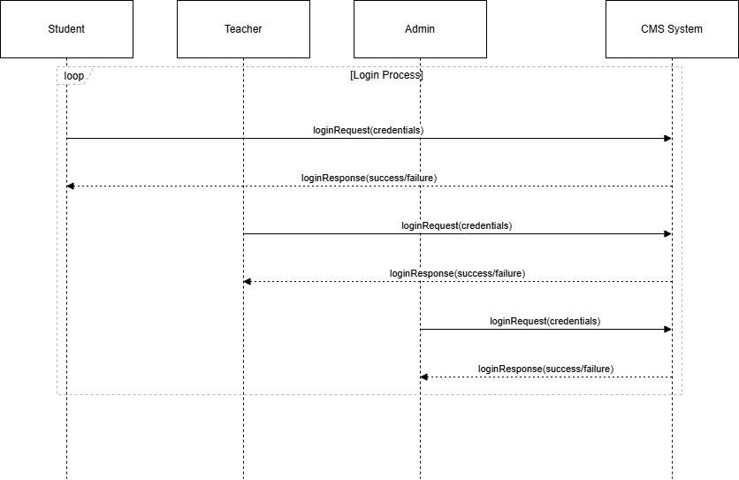
Figure 7.1

Admission:
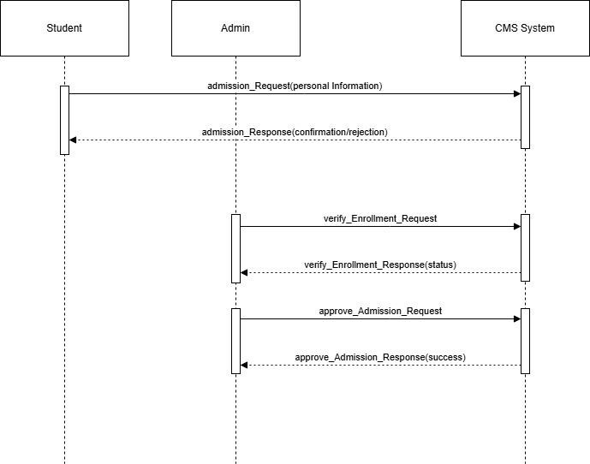
Figure: 7.2

Analytical Performance:
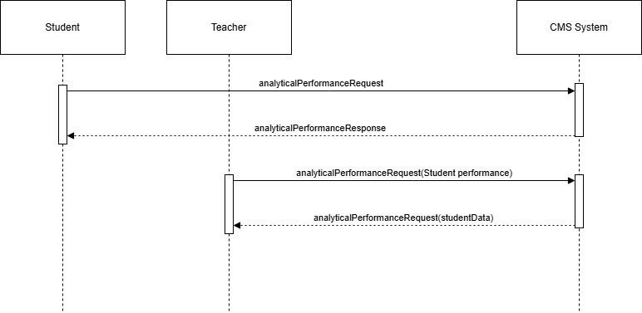
Figure: 7.3

Schedule:
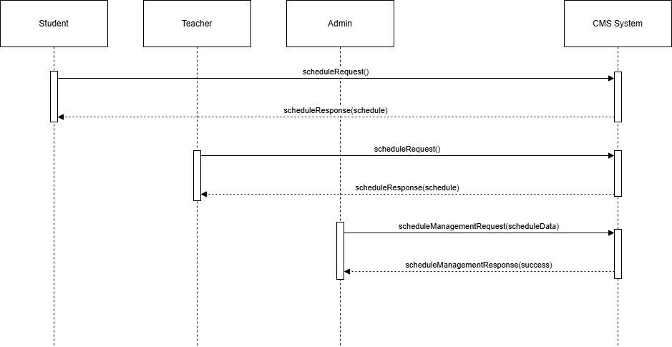

Figure: 7.4

Event:
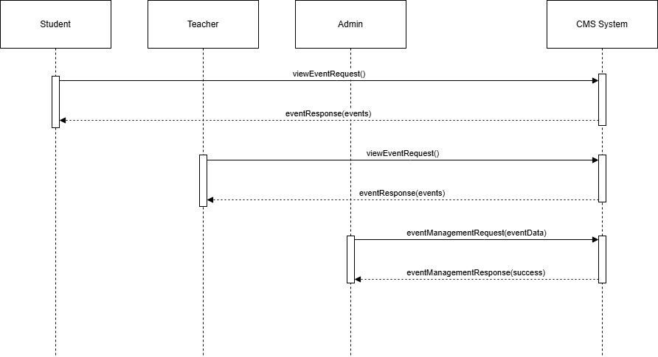
Figure: 7.5

Submit Assignment:
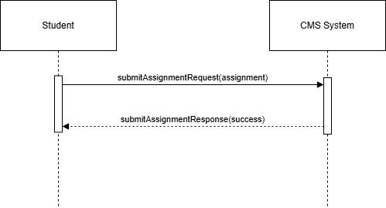
Figure: 7.6

Take Quiz:
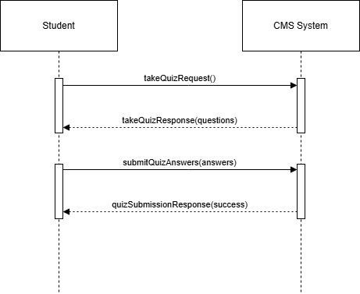
Figure 7.7

View Result
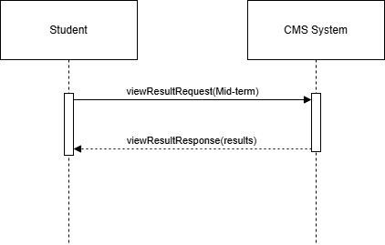
Figure: 7.8

Profile Management:
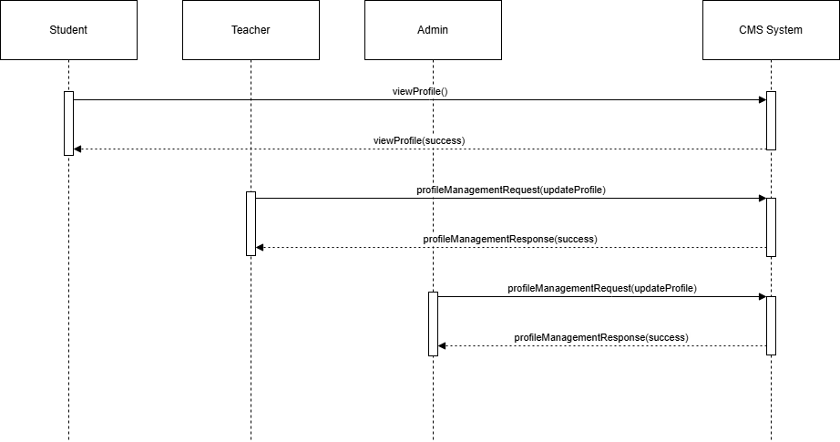
Figure: 7.9

Create Assignment:
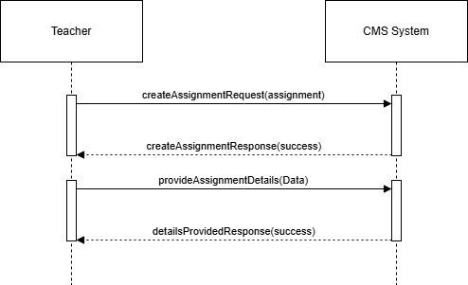
Figure: 7.10

Create Quiz:
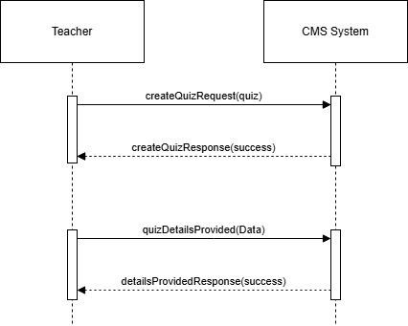
Figure: 7.11

Assign Grades:
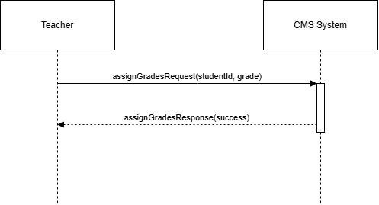
Figure:7.12

Admin Admission Management:
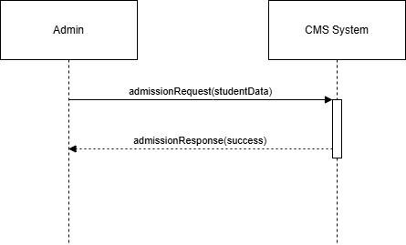
Figure:7.13

Admin Event Management:
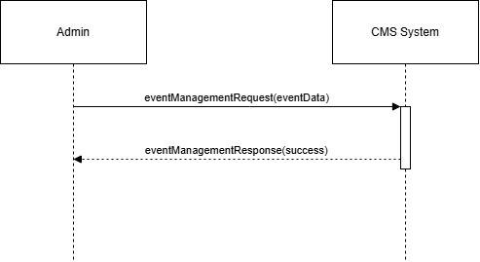

Figure:7.14

Chapter 8

CLASS DIAGRAM

Class Diagram:
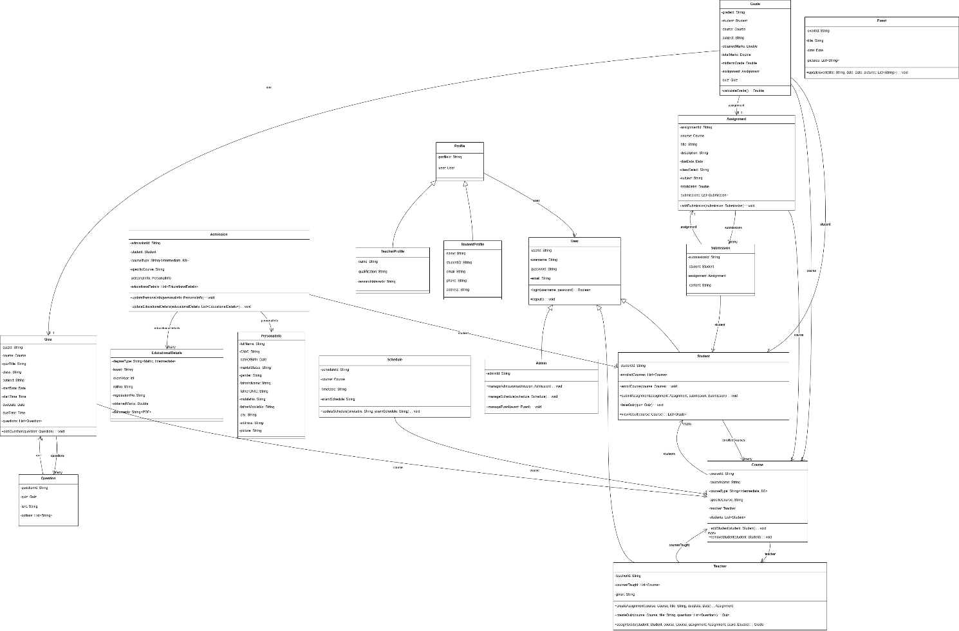

Figure:8.1

Chapter 9

Domain diagram

Domain Diagram:

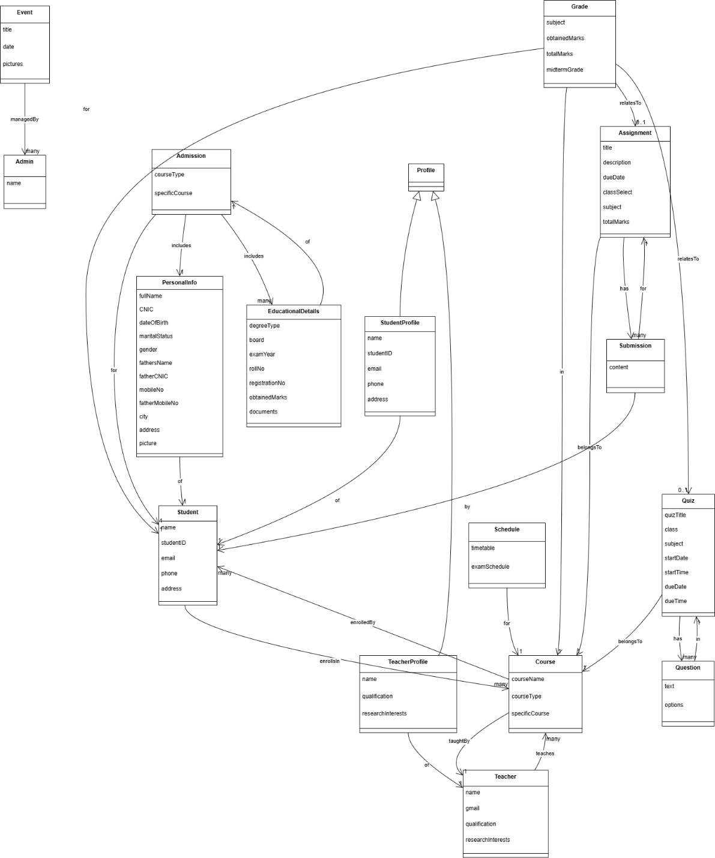

Figure:9.1

Chapter 10

Collaboration Diagram

Collaboration Diagram:
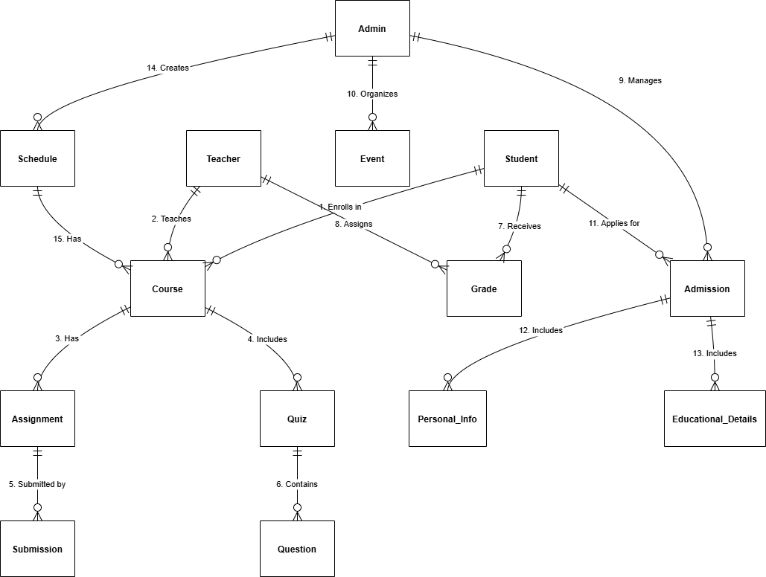

Figure:10.1

Chapter 11

Data Model

Data Model Diagram:
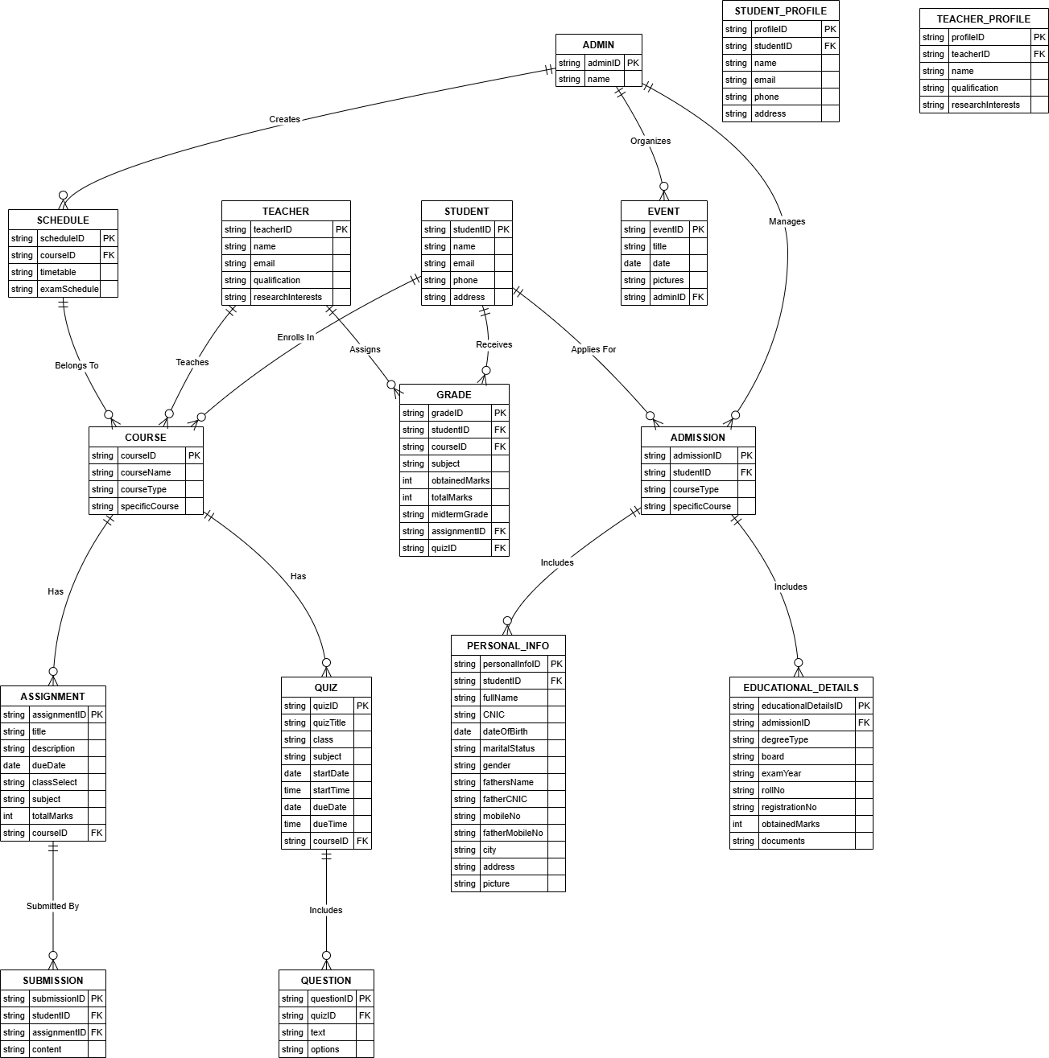
Figure: 11.1

CHAPTER 12

PROJECT INTERFACES

12.1 Admission Screen

12.1.1 Course Selection
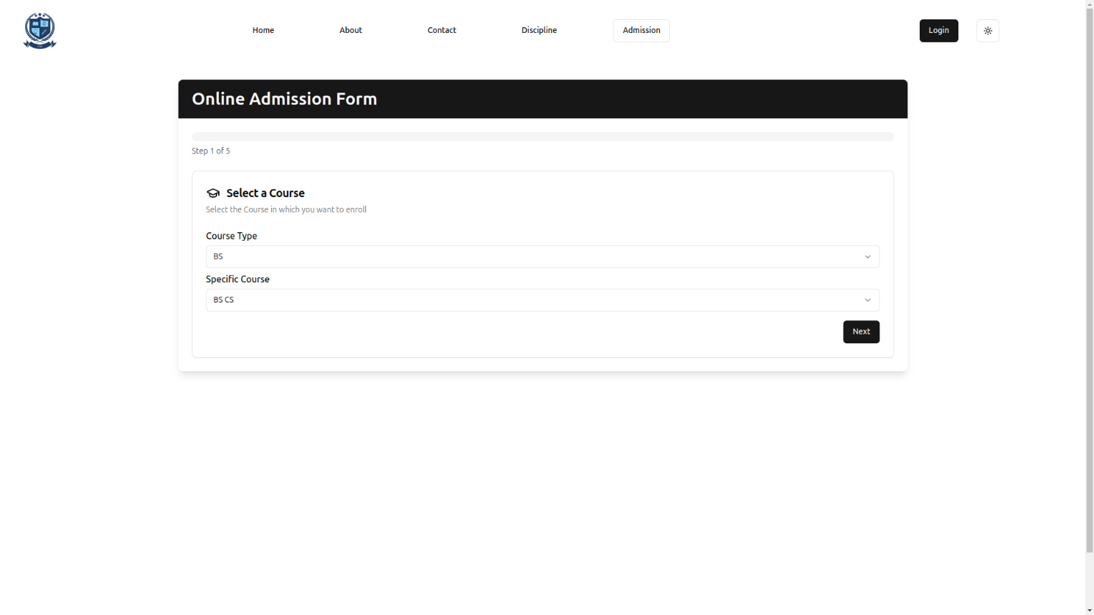

12.1.2 Personal Information
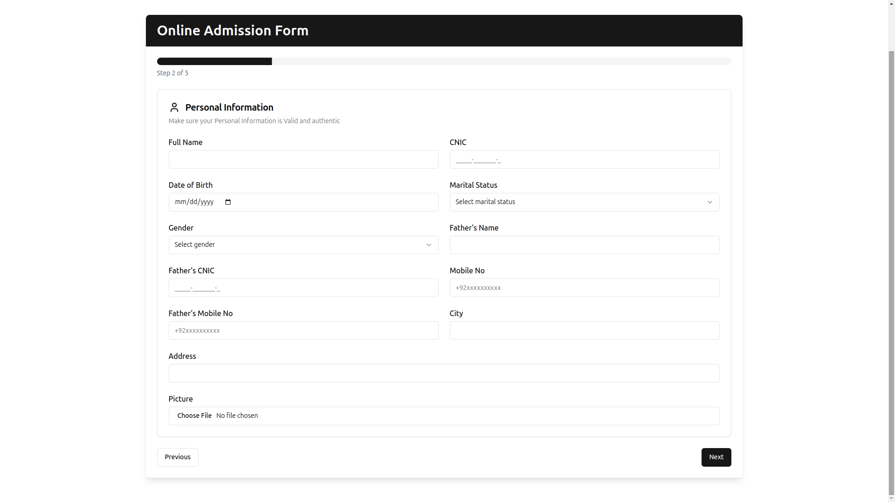

12.1.3 Educational Details
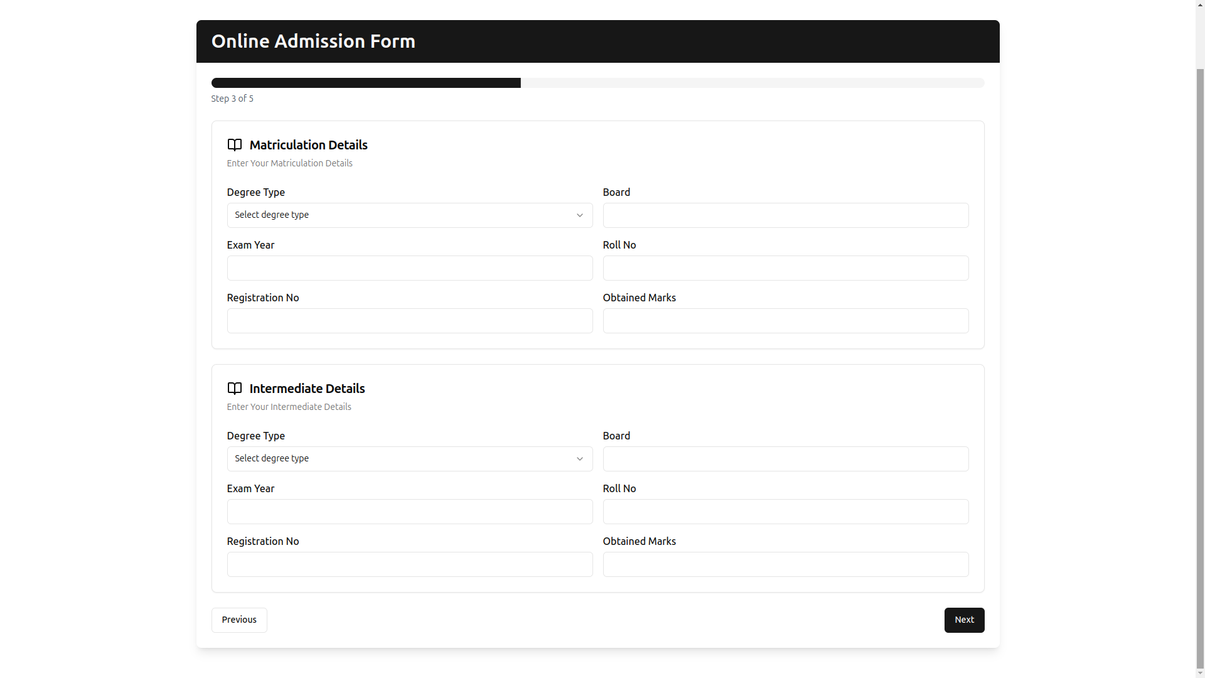

12.1.4 Upload Documents
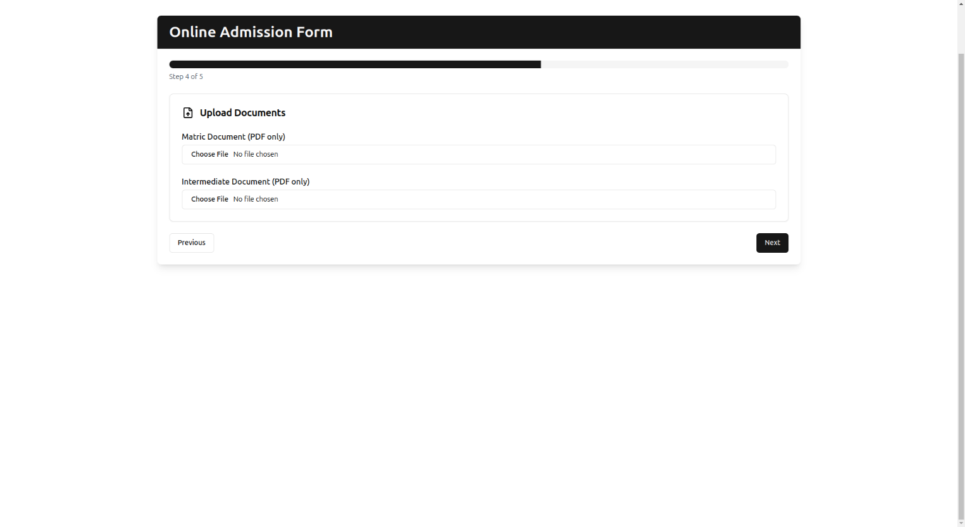

12.2 Student Pages
12.2.1 Student Dashboard
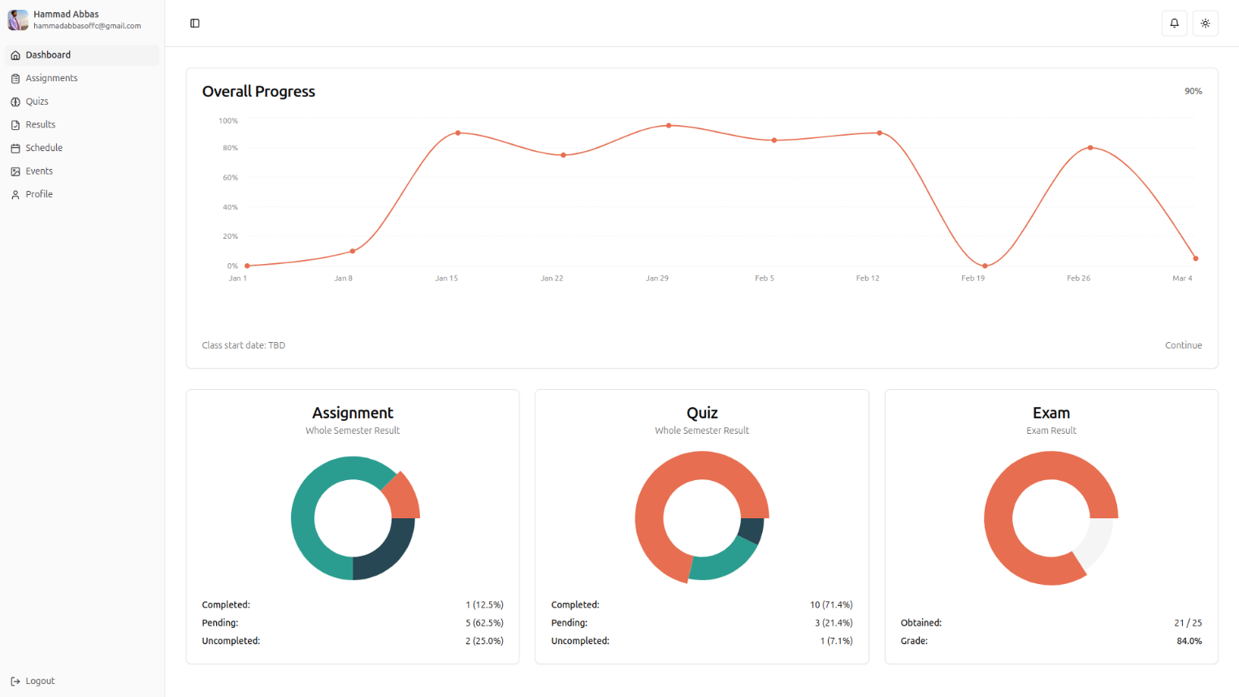

12.2.2 Student Assignment
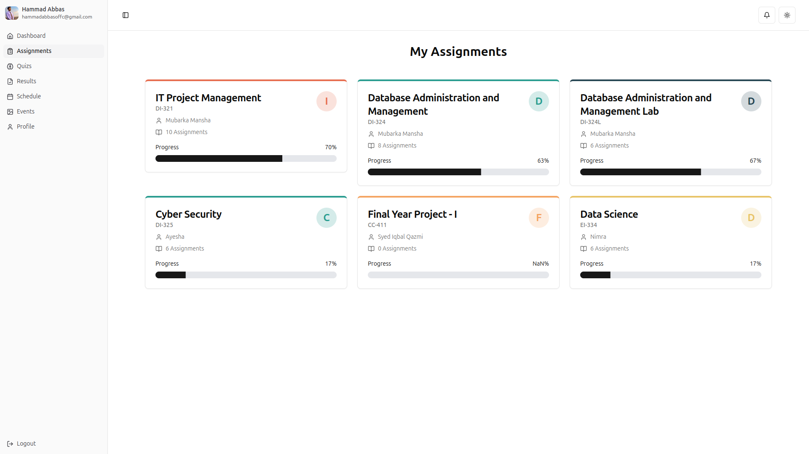

12.2.3 Submit Assignment Page
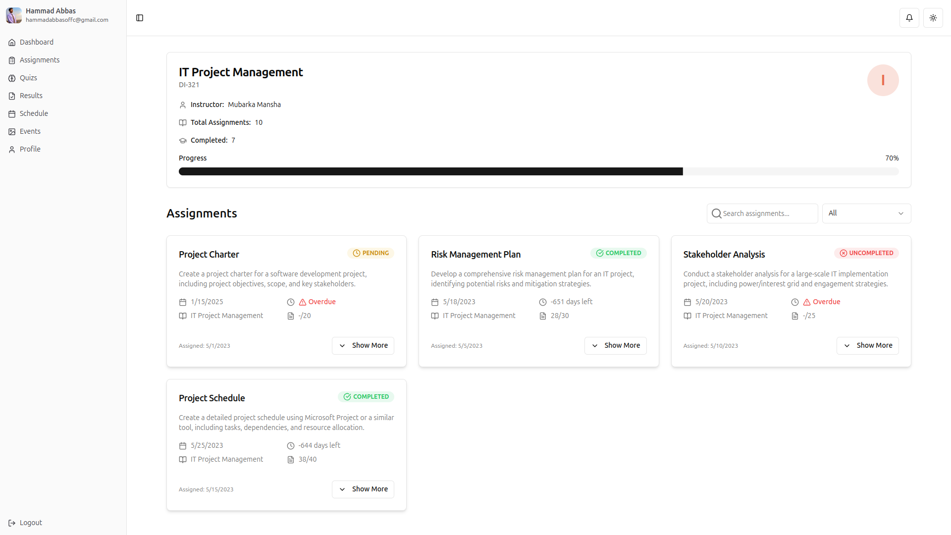

12.3 Student Quiz
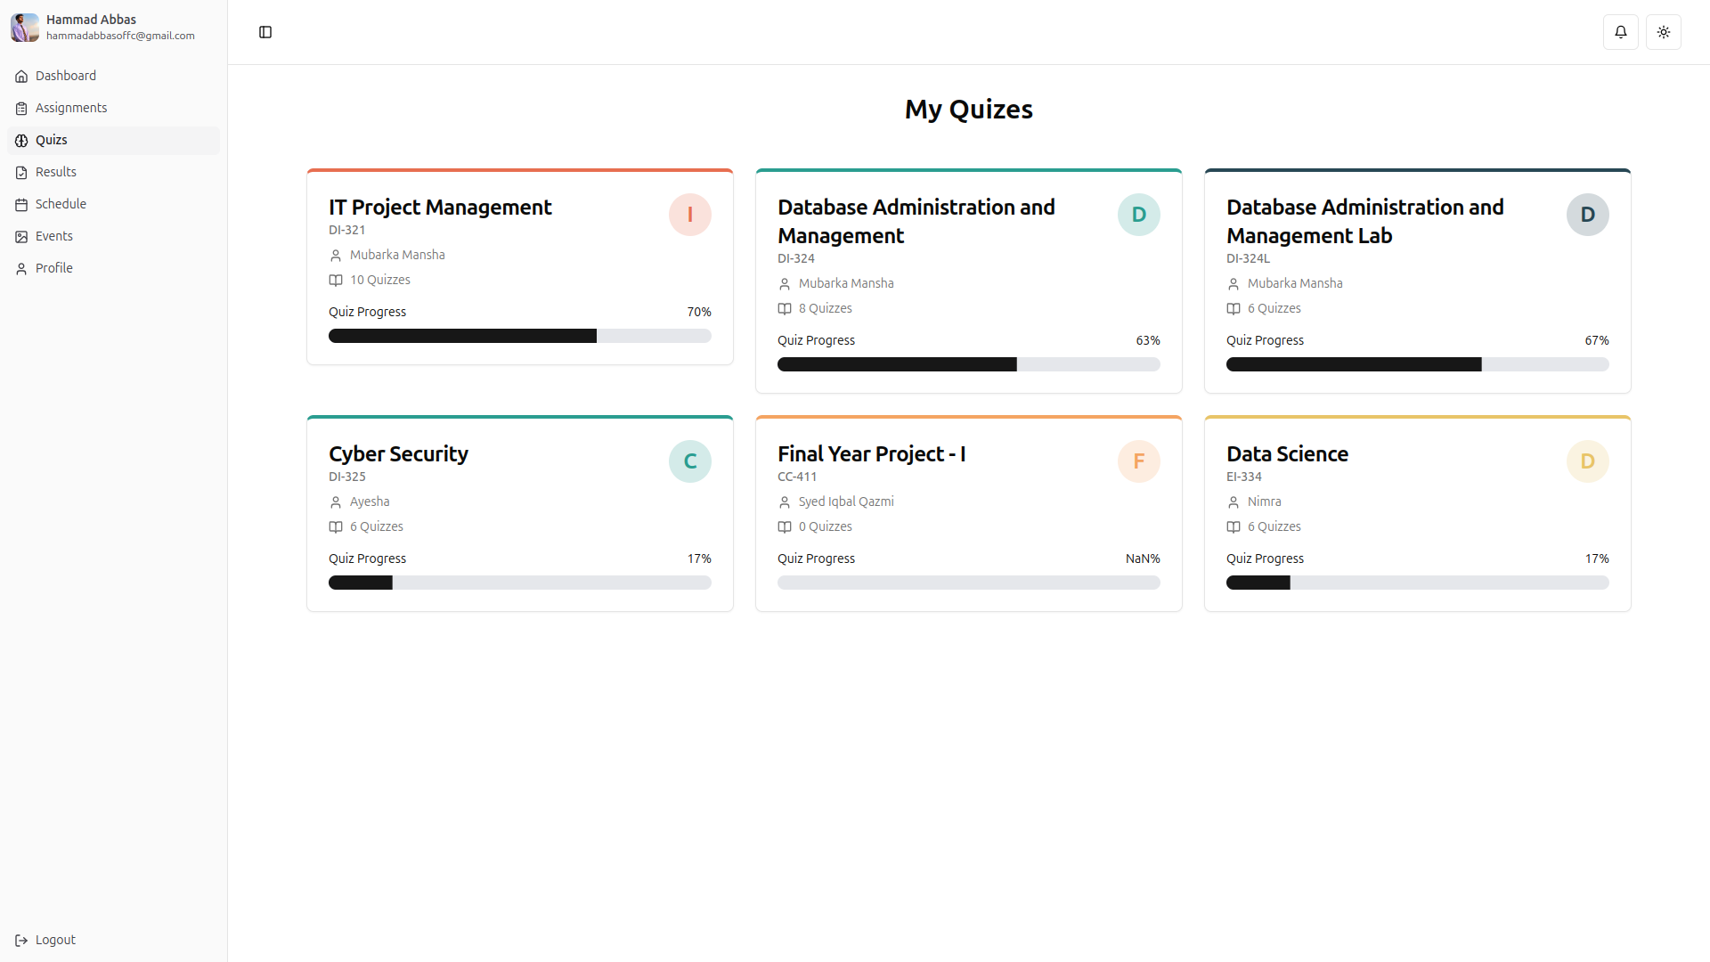

12.3.1 Student Quiz Details
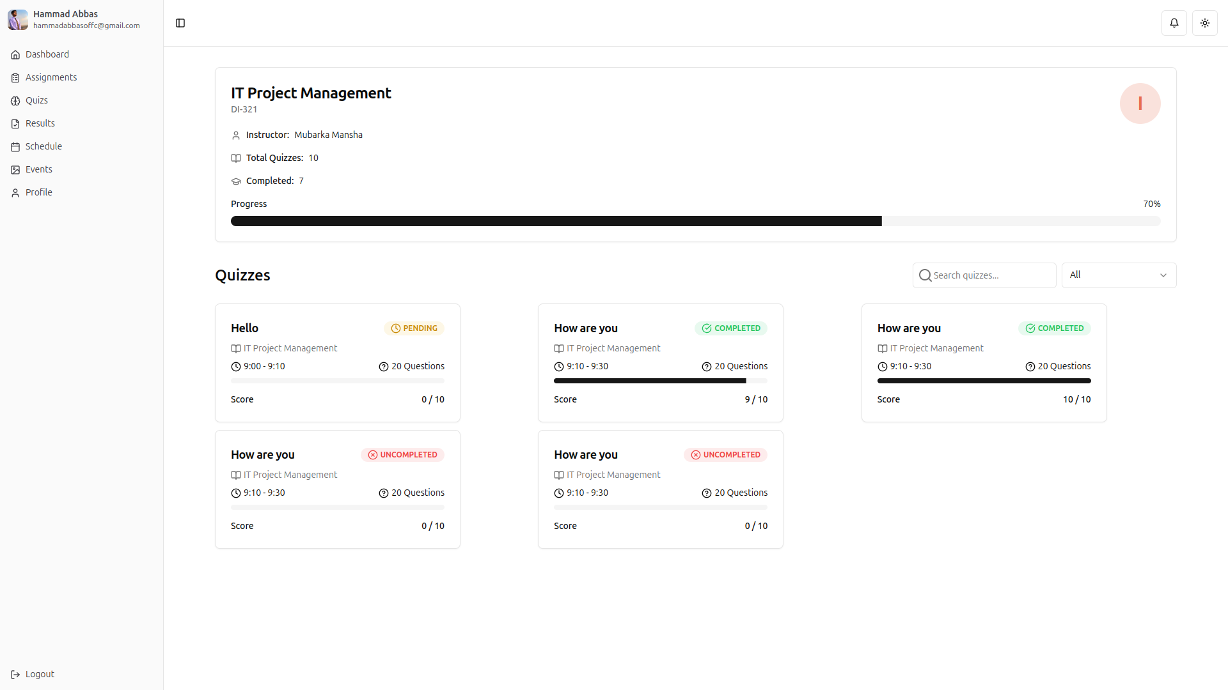

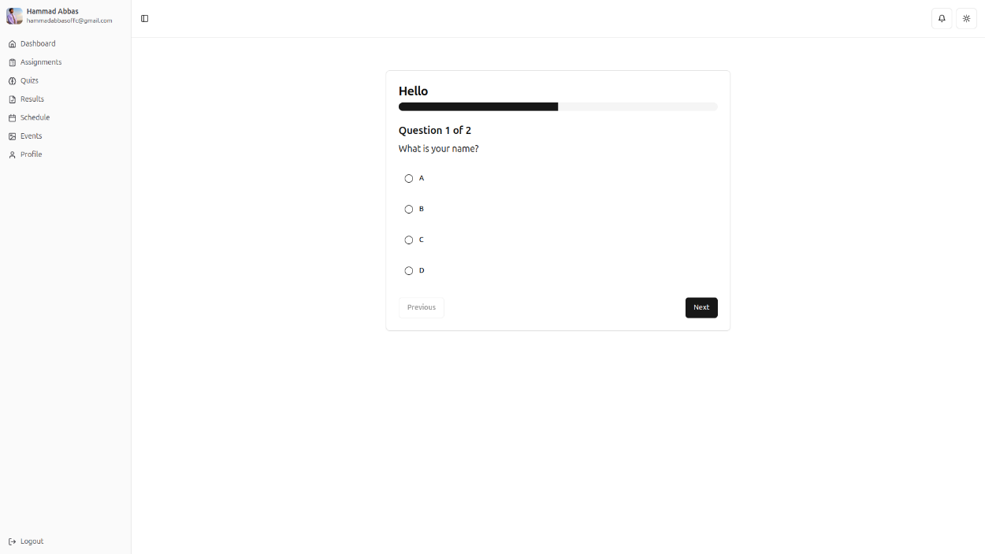
12.3.2 Student Submit Quiz
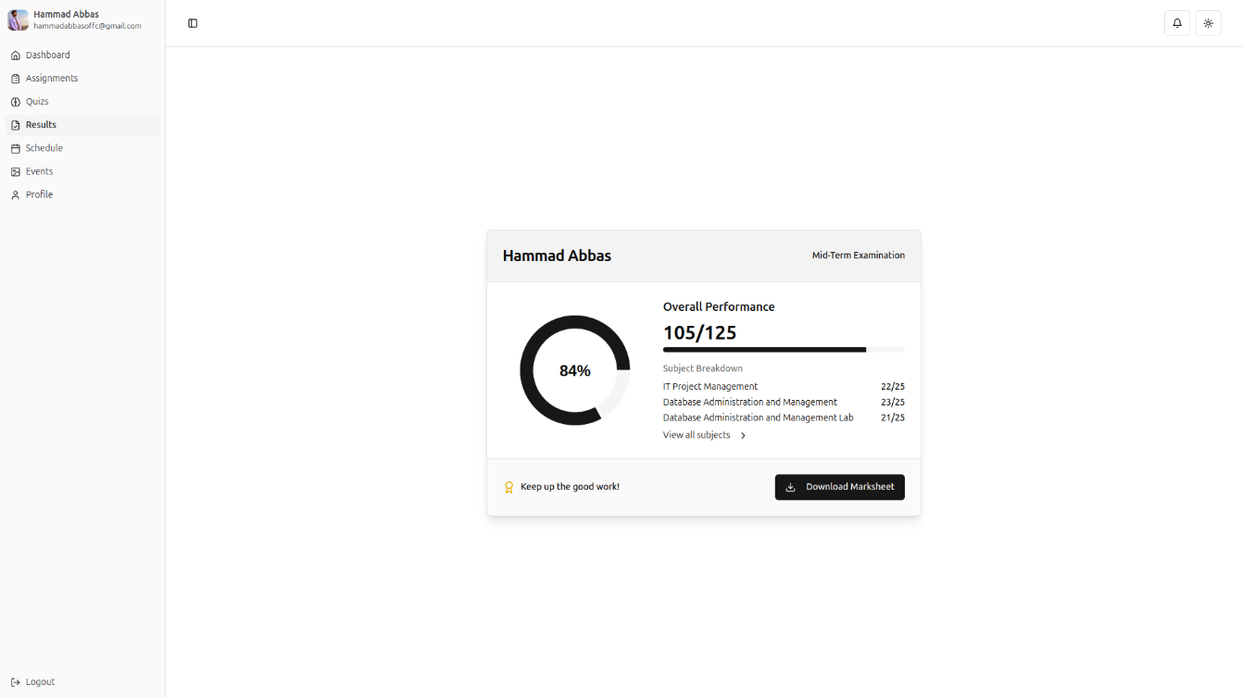
12.4 Student Grades

12.4.1

12.4. Login
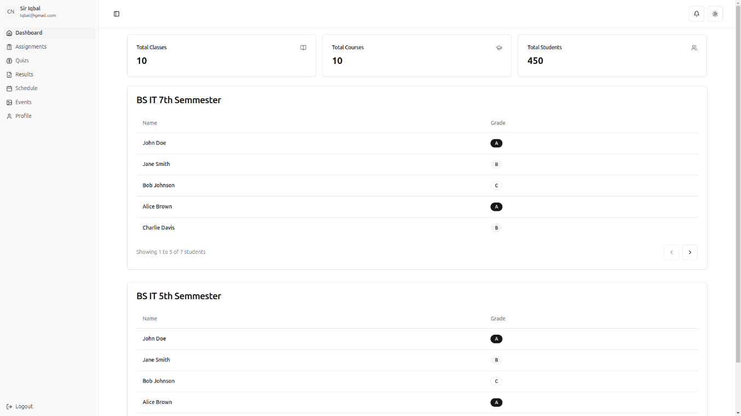

12.1.13 Login

12.1.14 Login
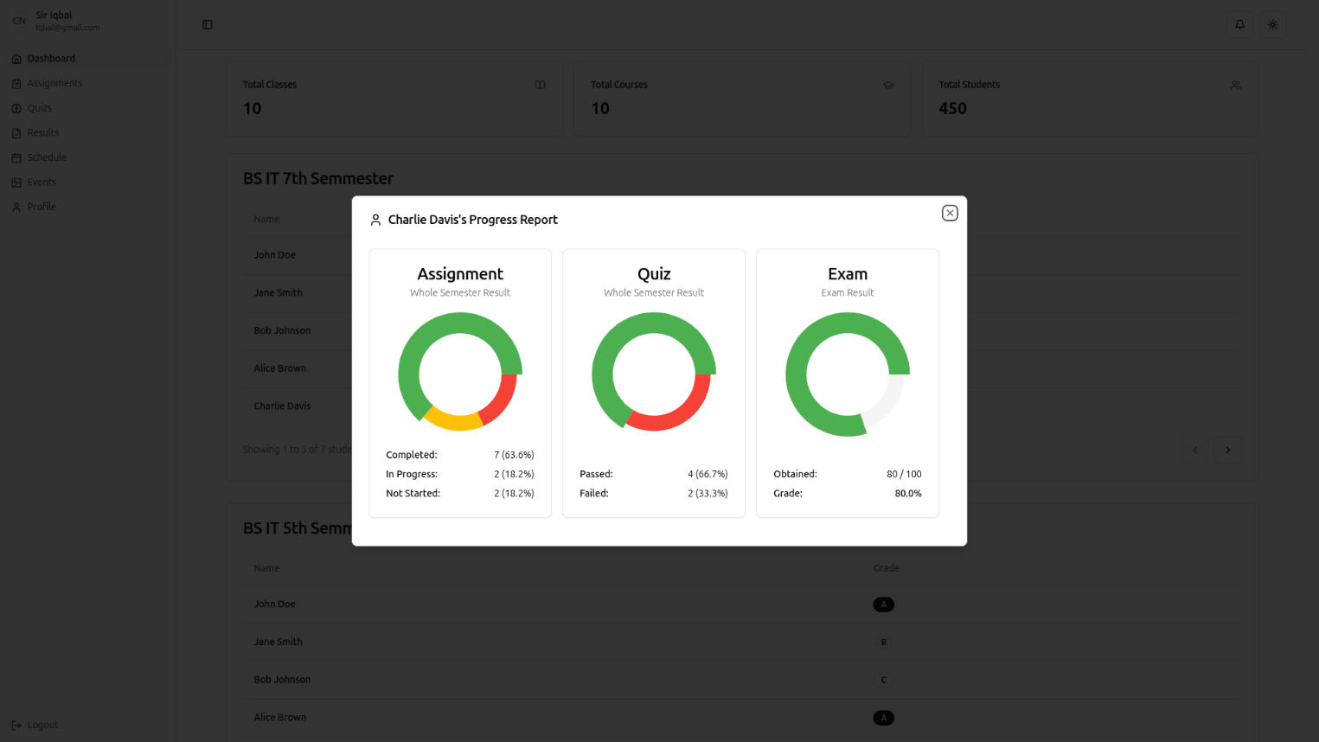

12.1.15 Login
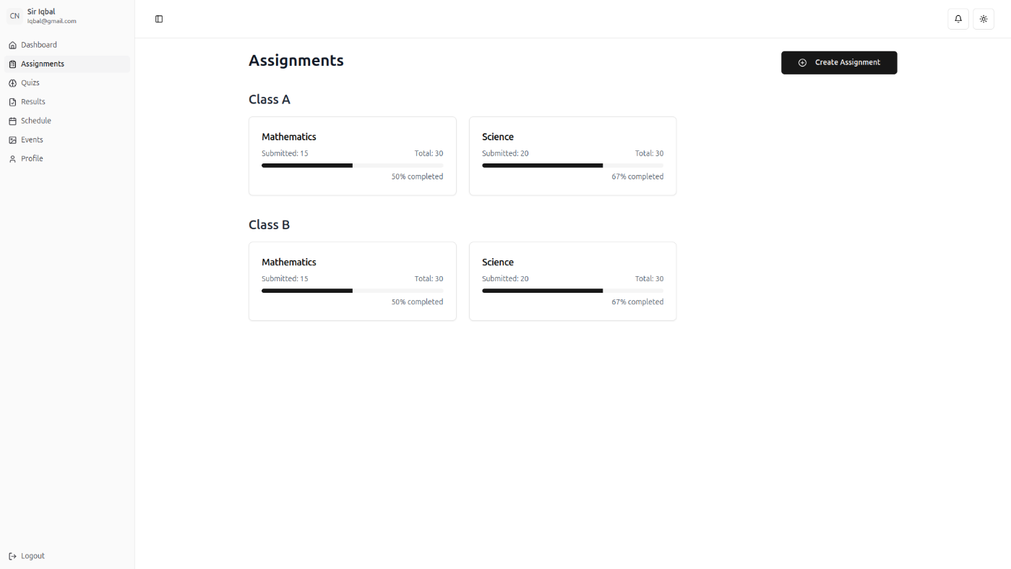

12.1.16 Login
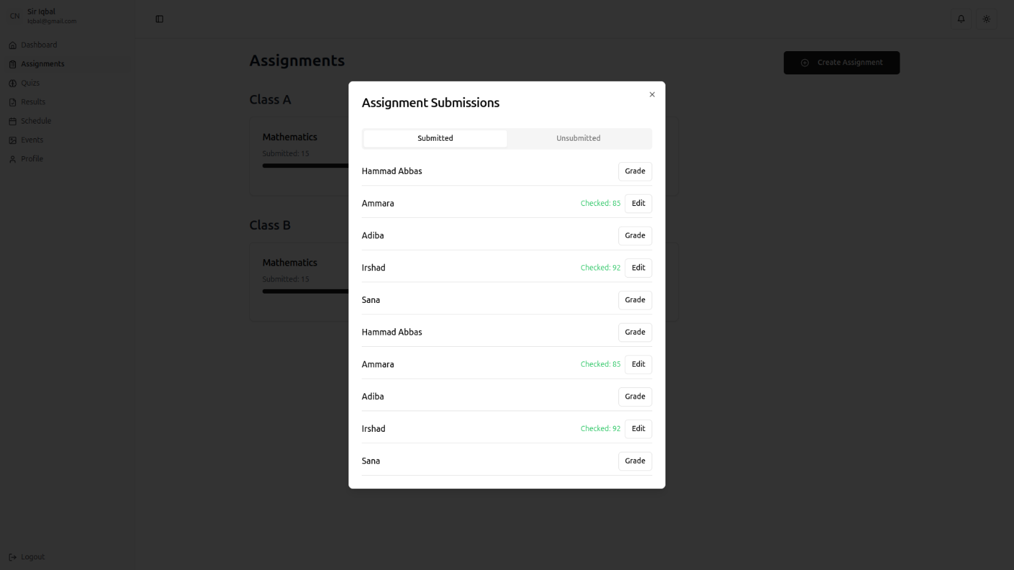

12.1.17 Login
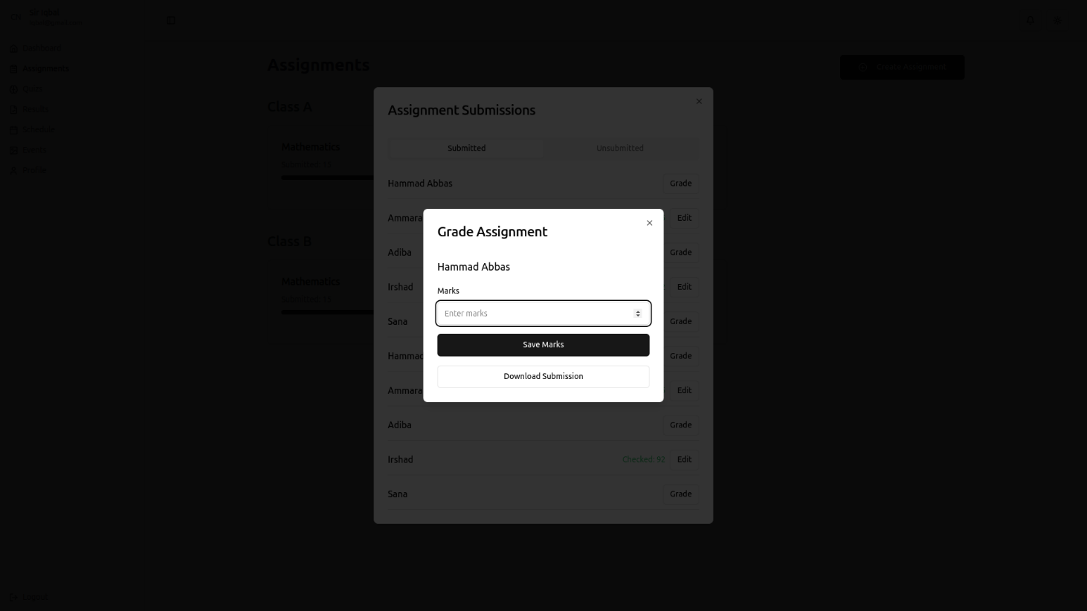

12.1.18 Login
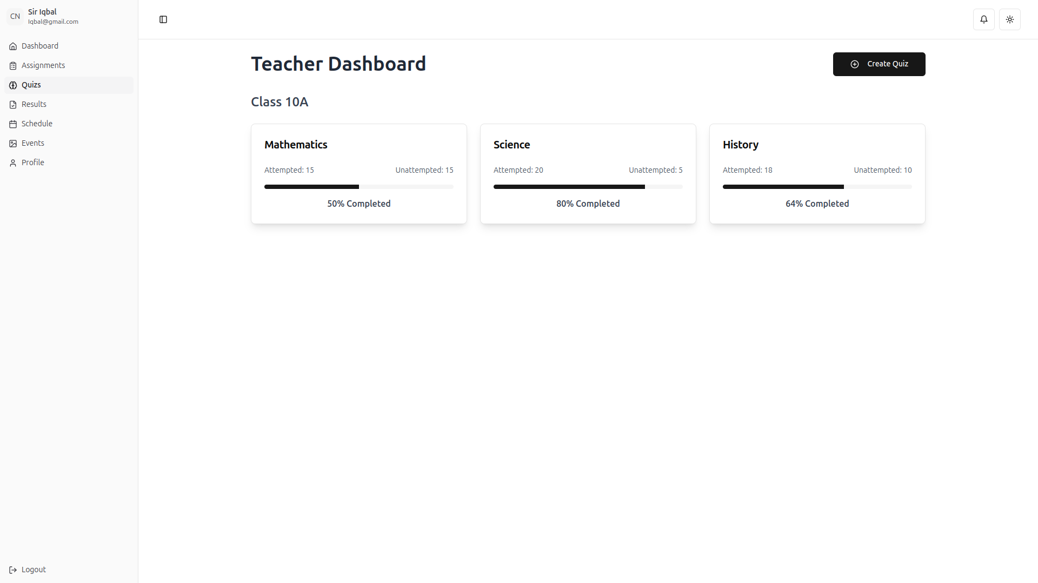

12.1.19 Login
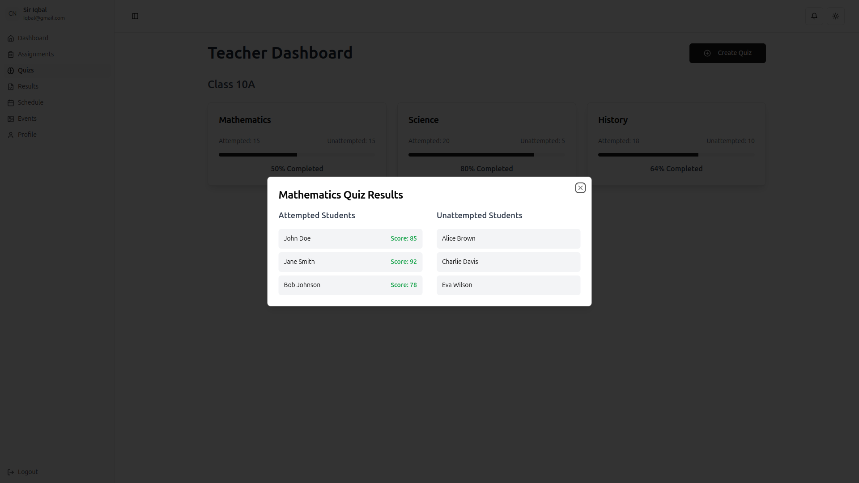
12.1.20 Login
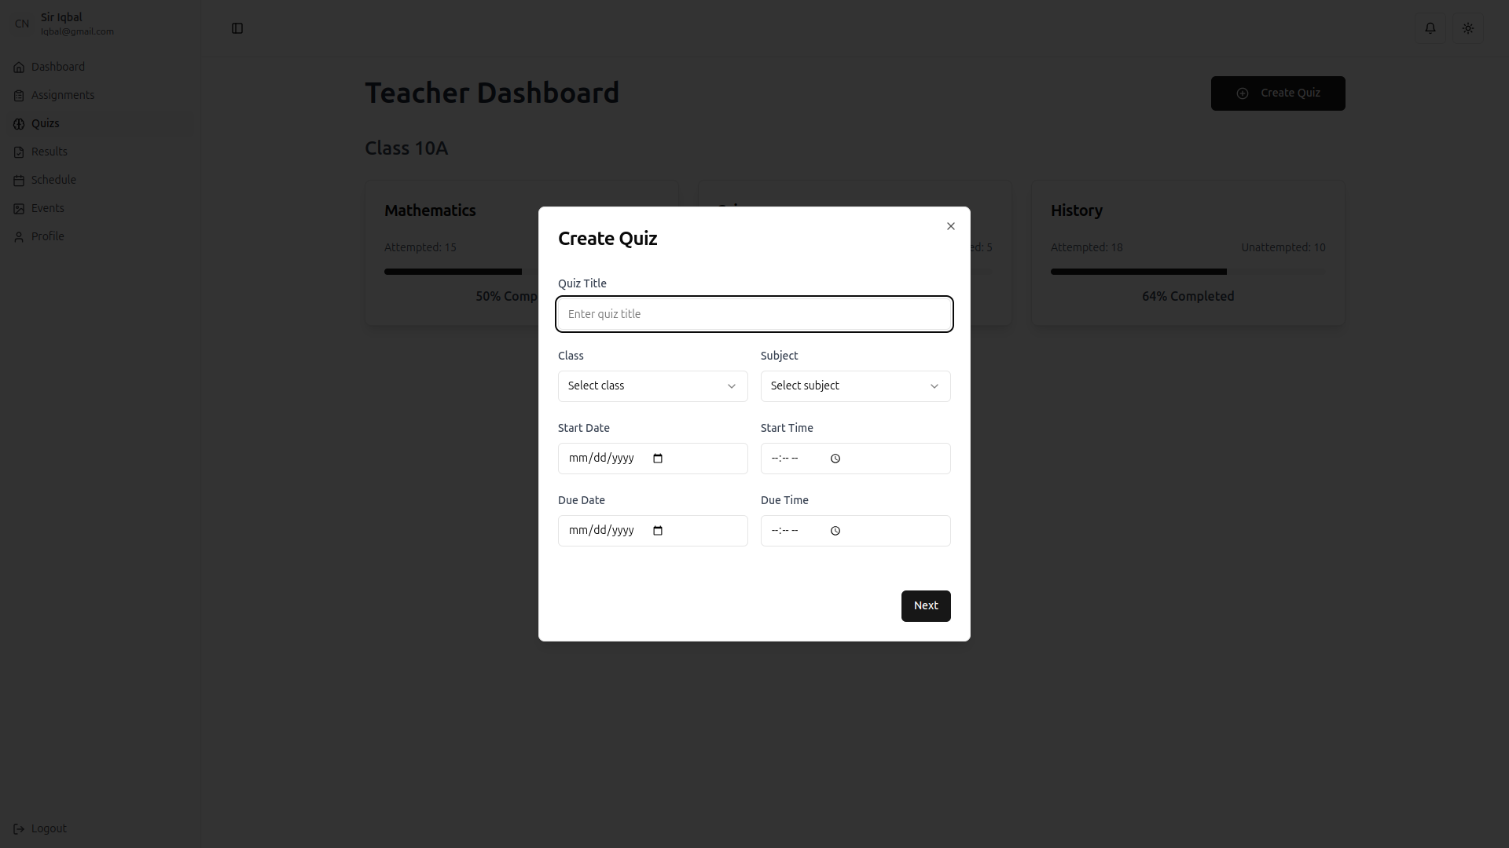

12.1.21 Login
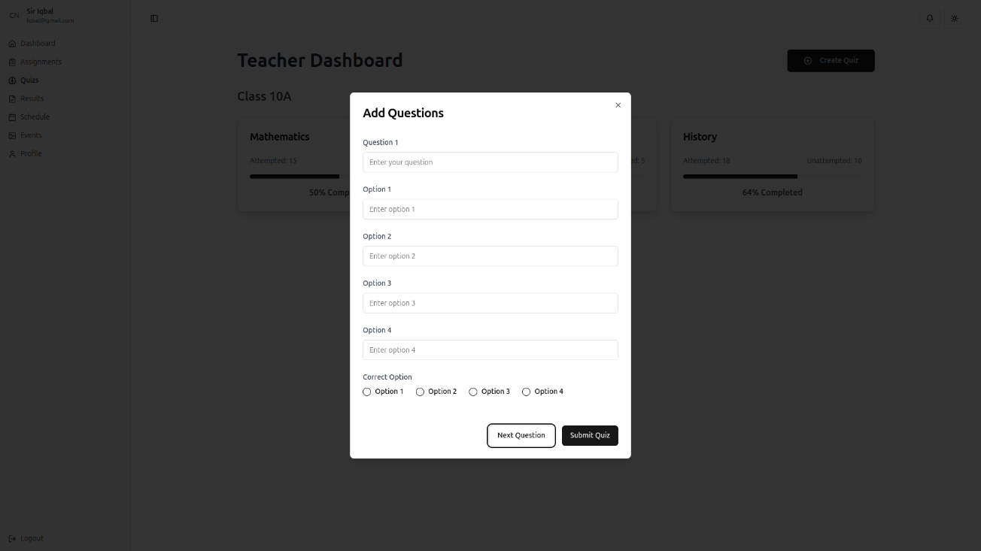

12.1.22 Login

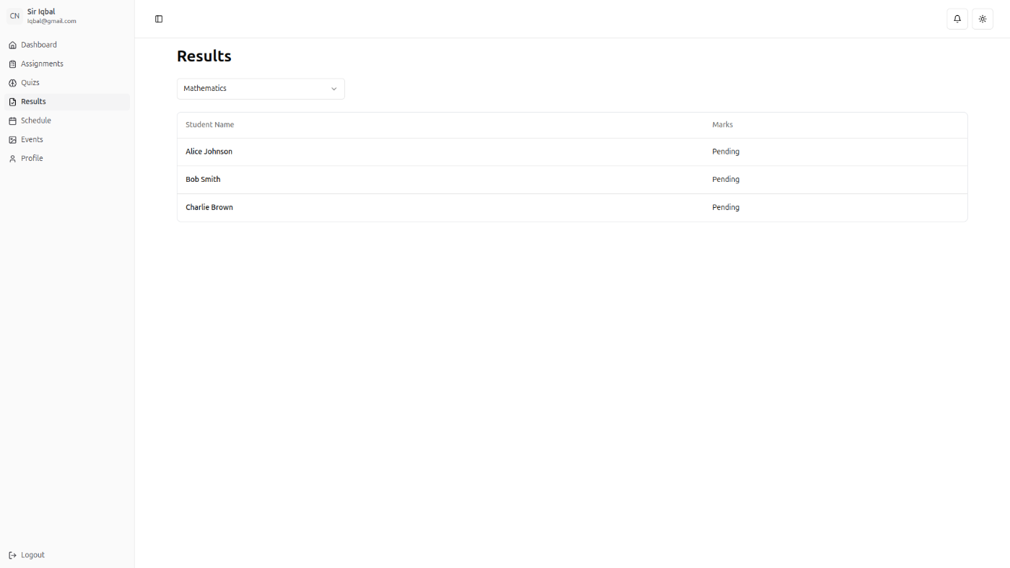

12.1.23 Login
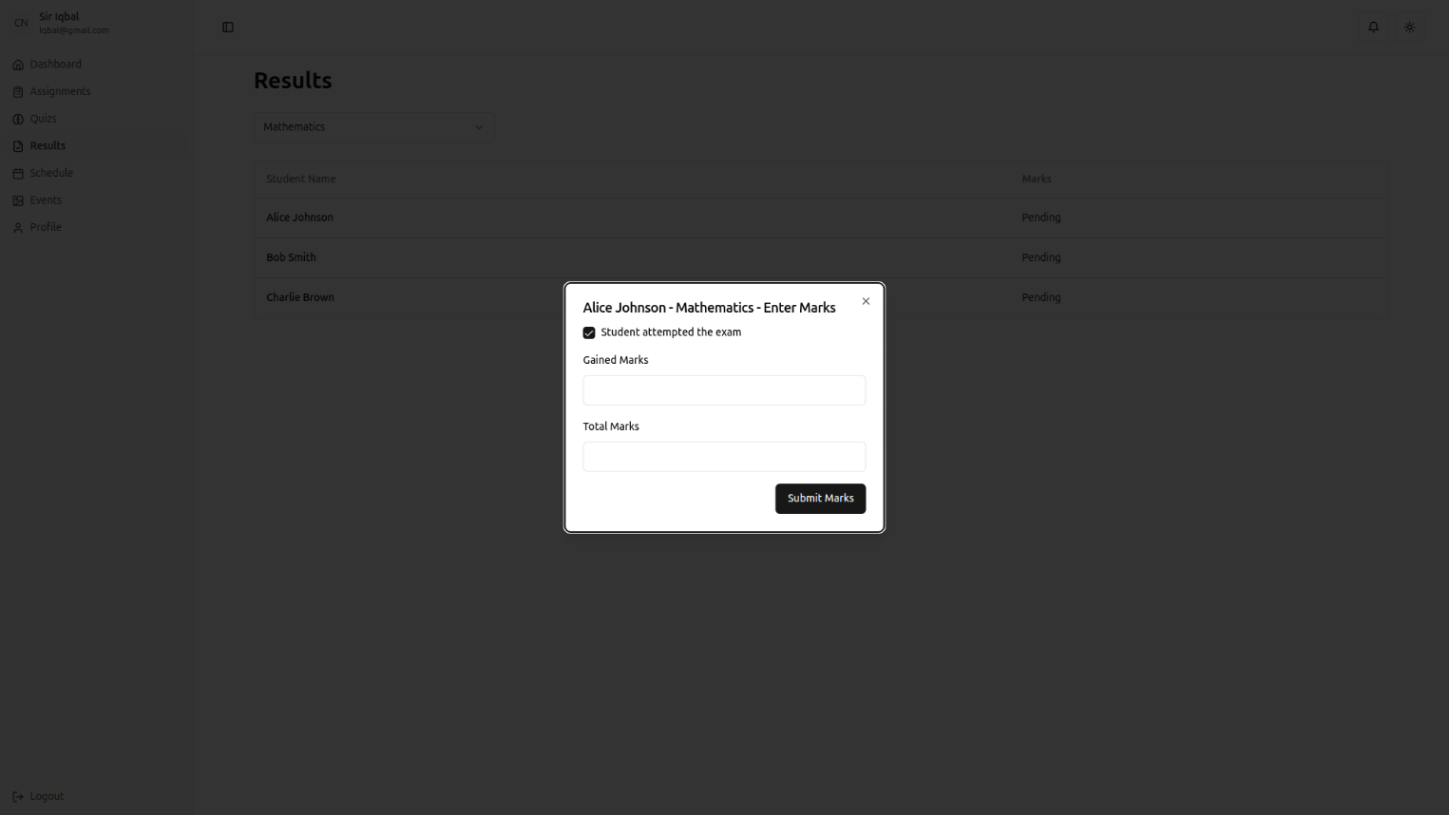
12.1.24 Login
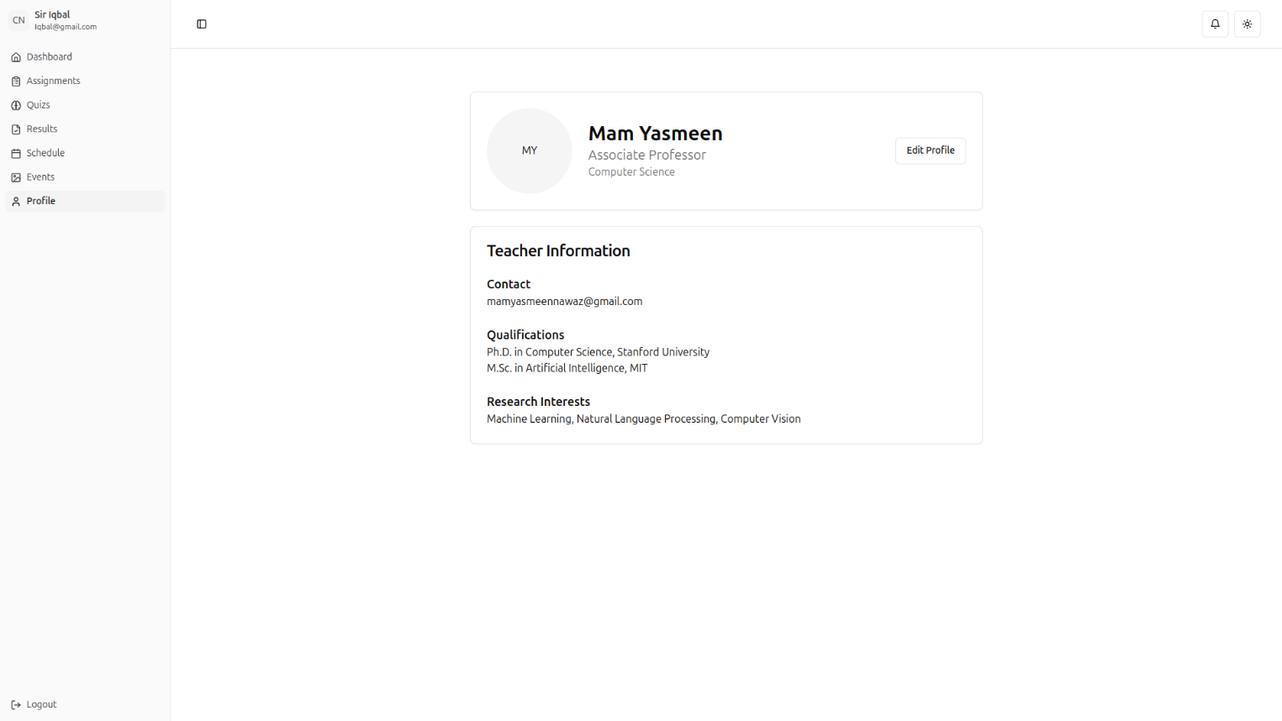

12.1.25 Login
